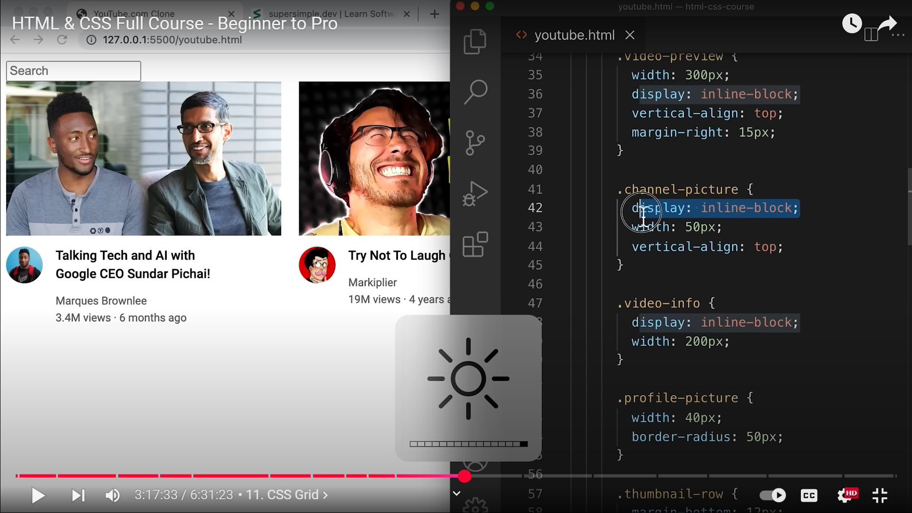  
For our horizontal layout, which is the channel’s profile picture and then video info, we did this using display: inline-block;  
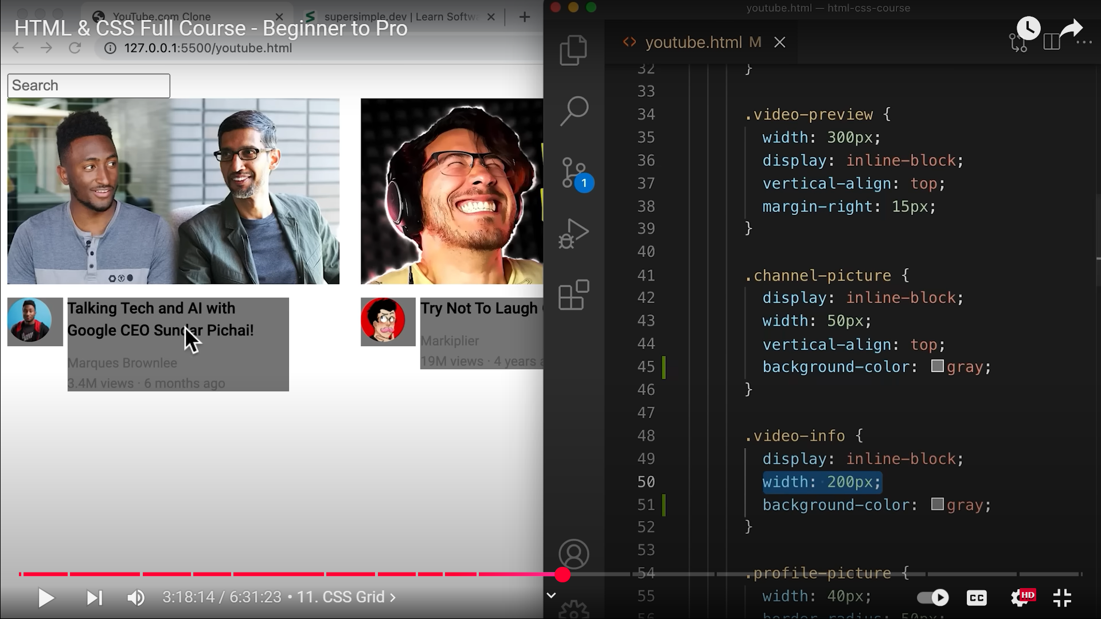  
There is some space between the two  
**display: inline-block; HAS SOME ALIGNMENT ISSUES!!!!!!!!!!!!!!**  
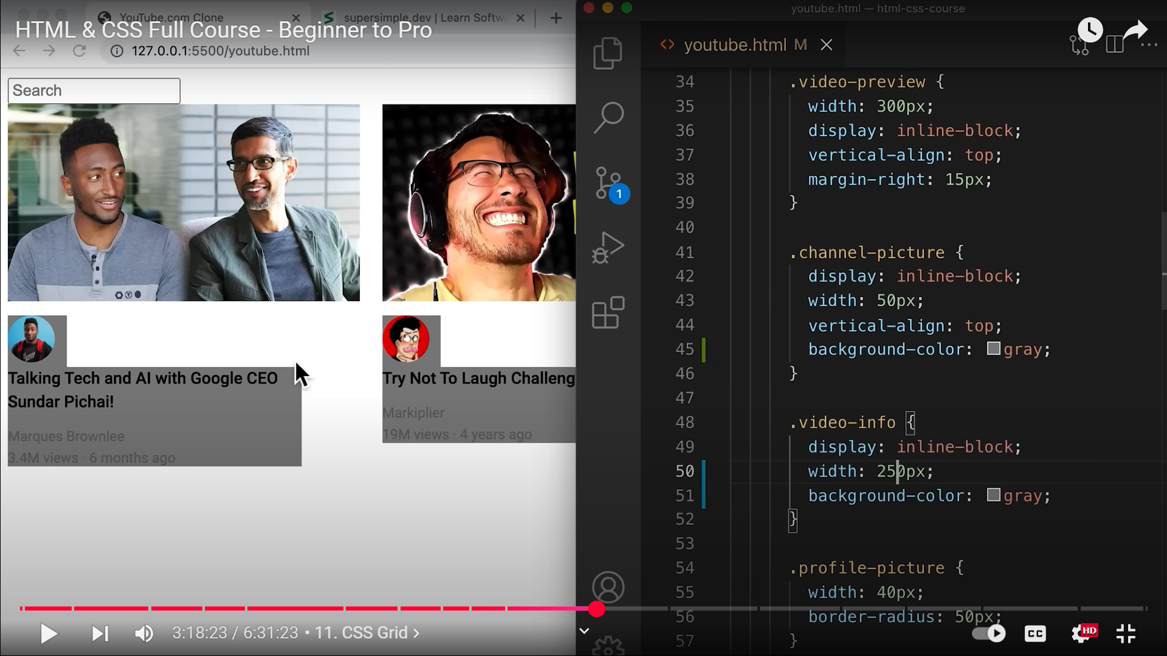  
  
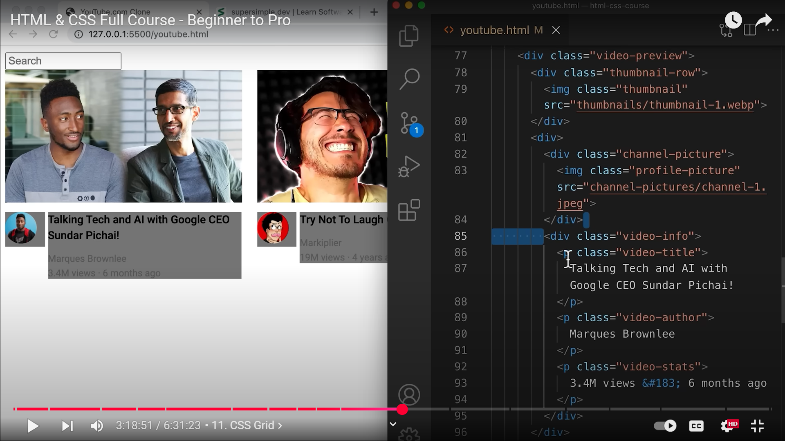  
**THIS SPACE IS COMING DUE TO THE SPACE BETWEEN THE TWO DIVS. HTML COMBINES MULTIPLE SPACE AND THAT’S WHAT CAUSES THIS SPACE!!!!!!!!!!!!!!!!!!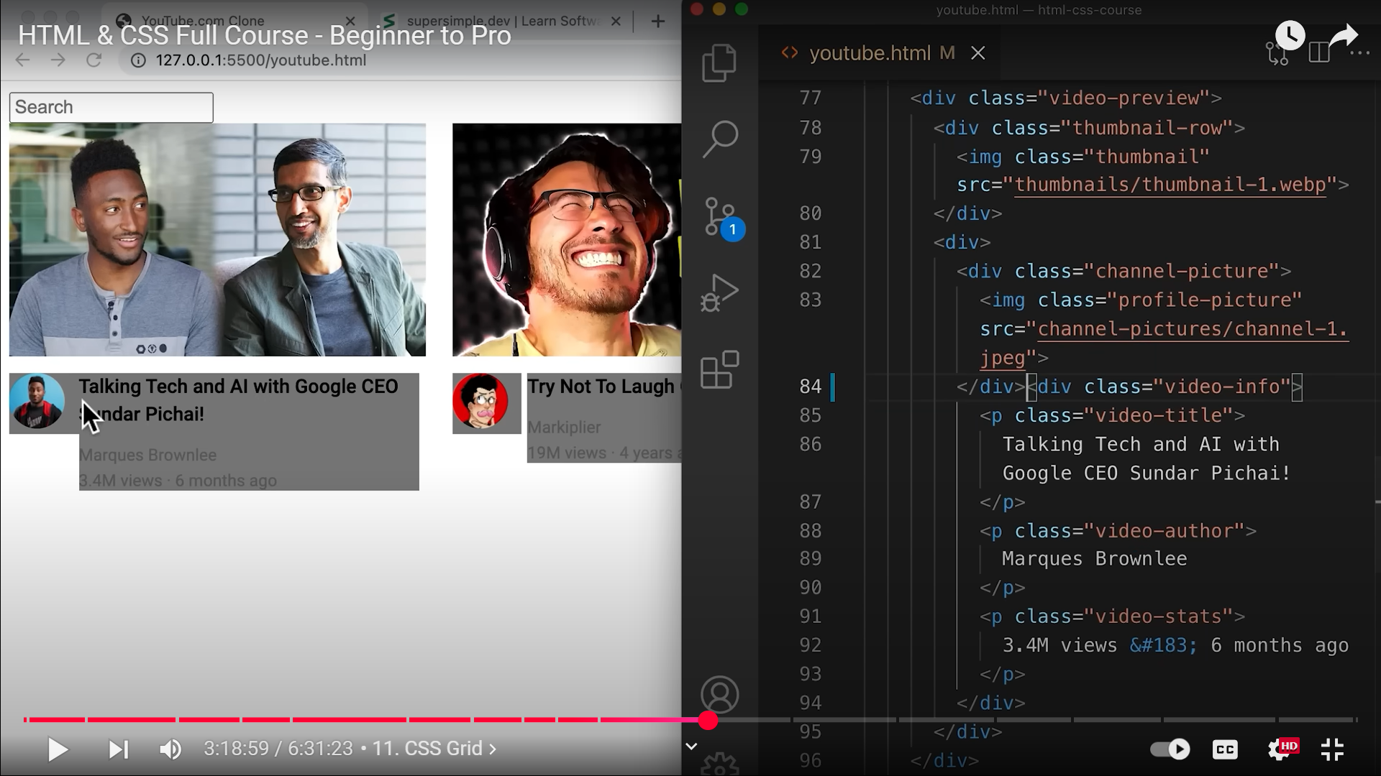 84, BUT THE CODE IS LESS EASIER TO READ**

**PRACTICING CSS GRID: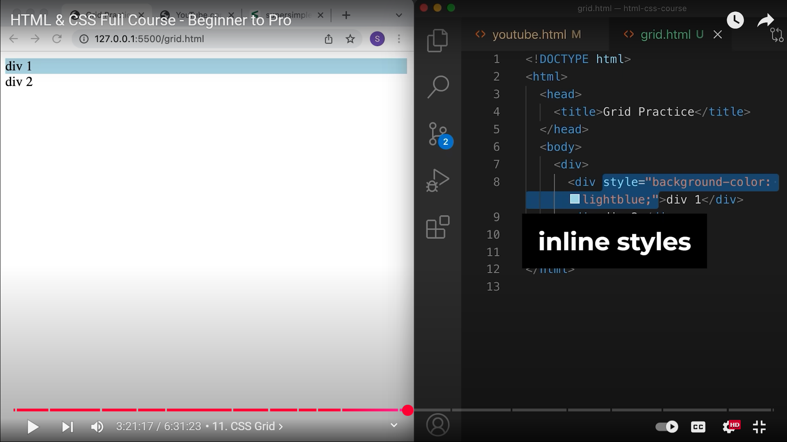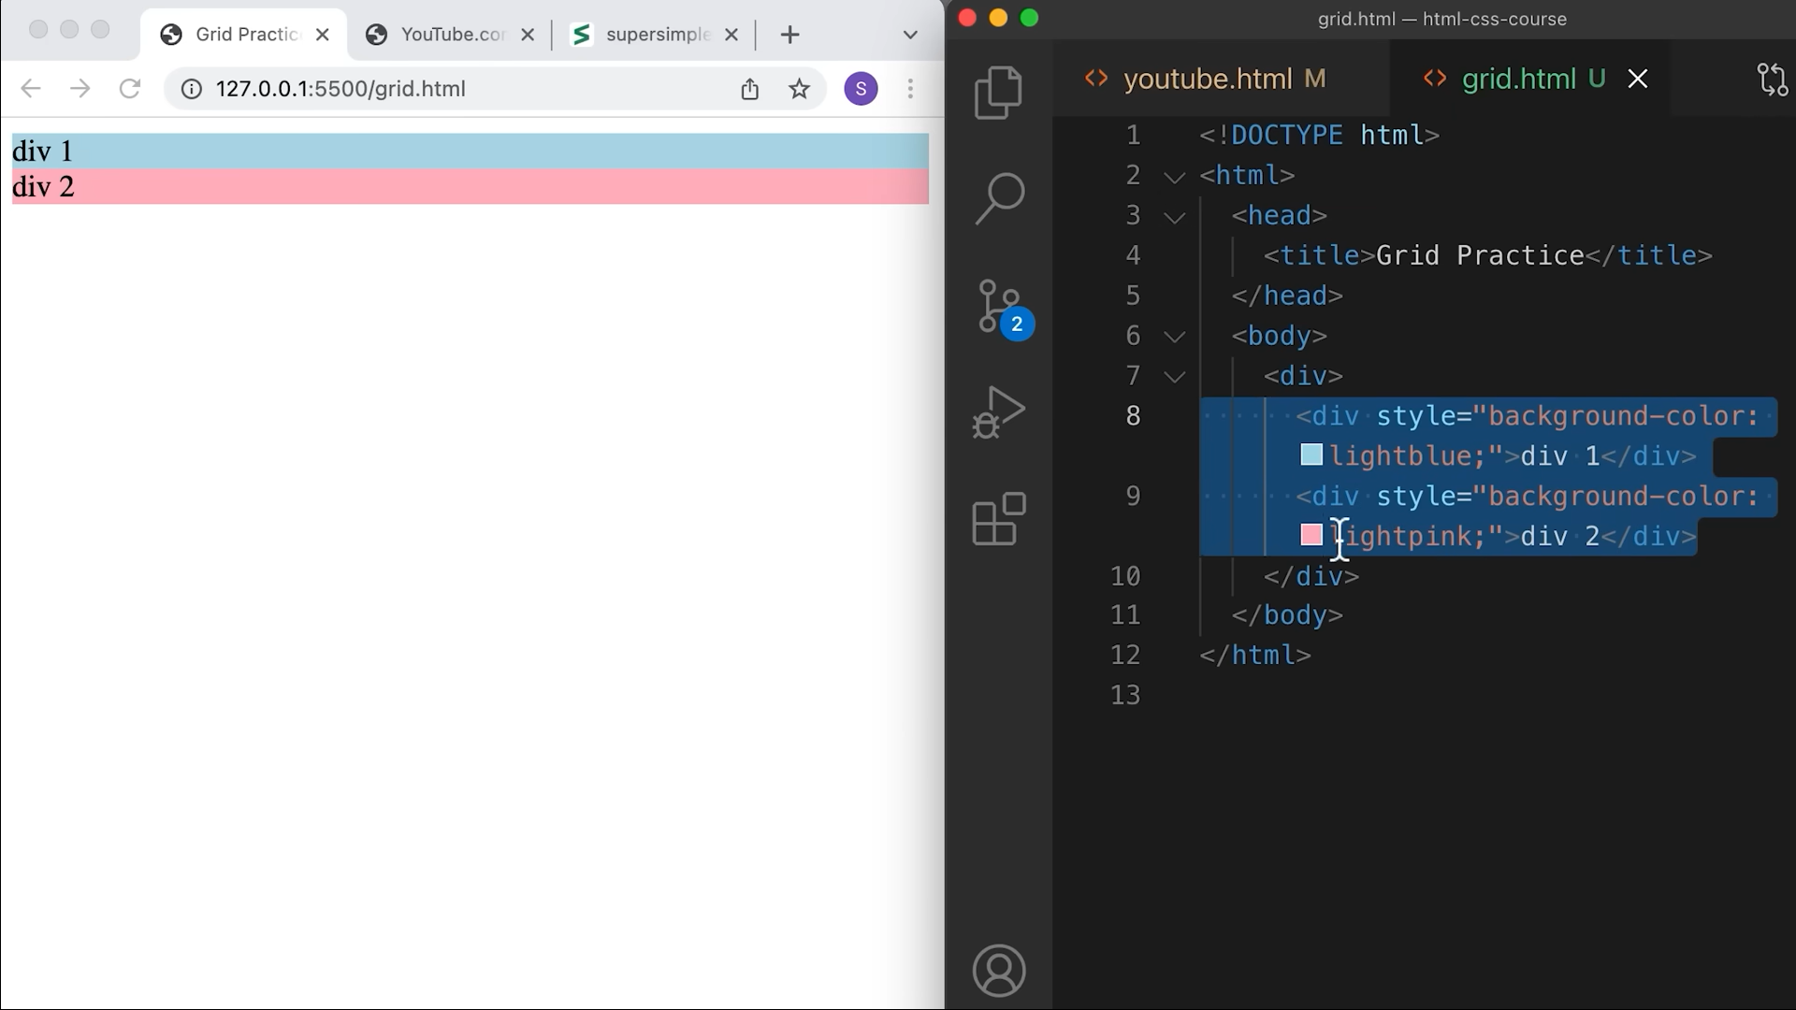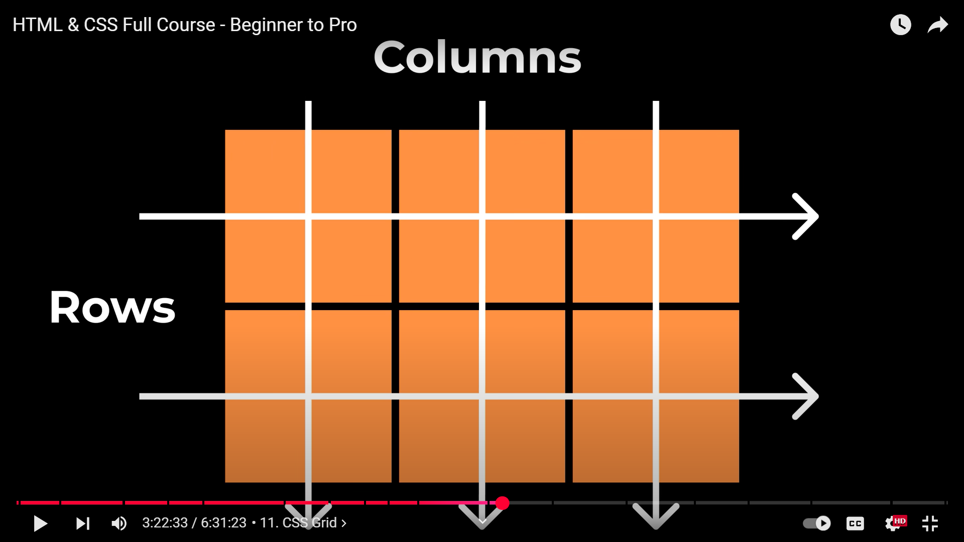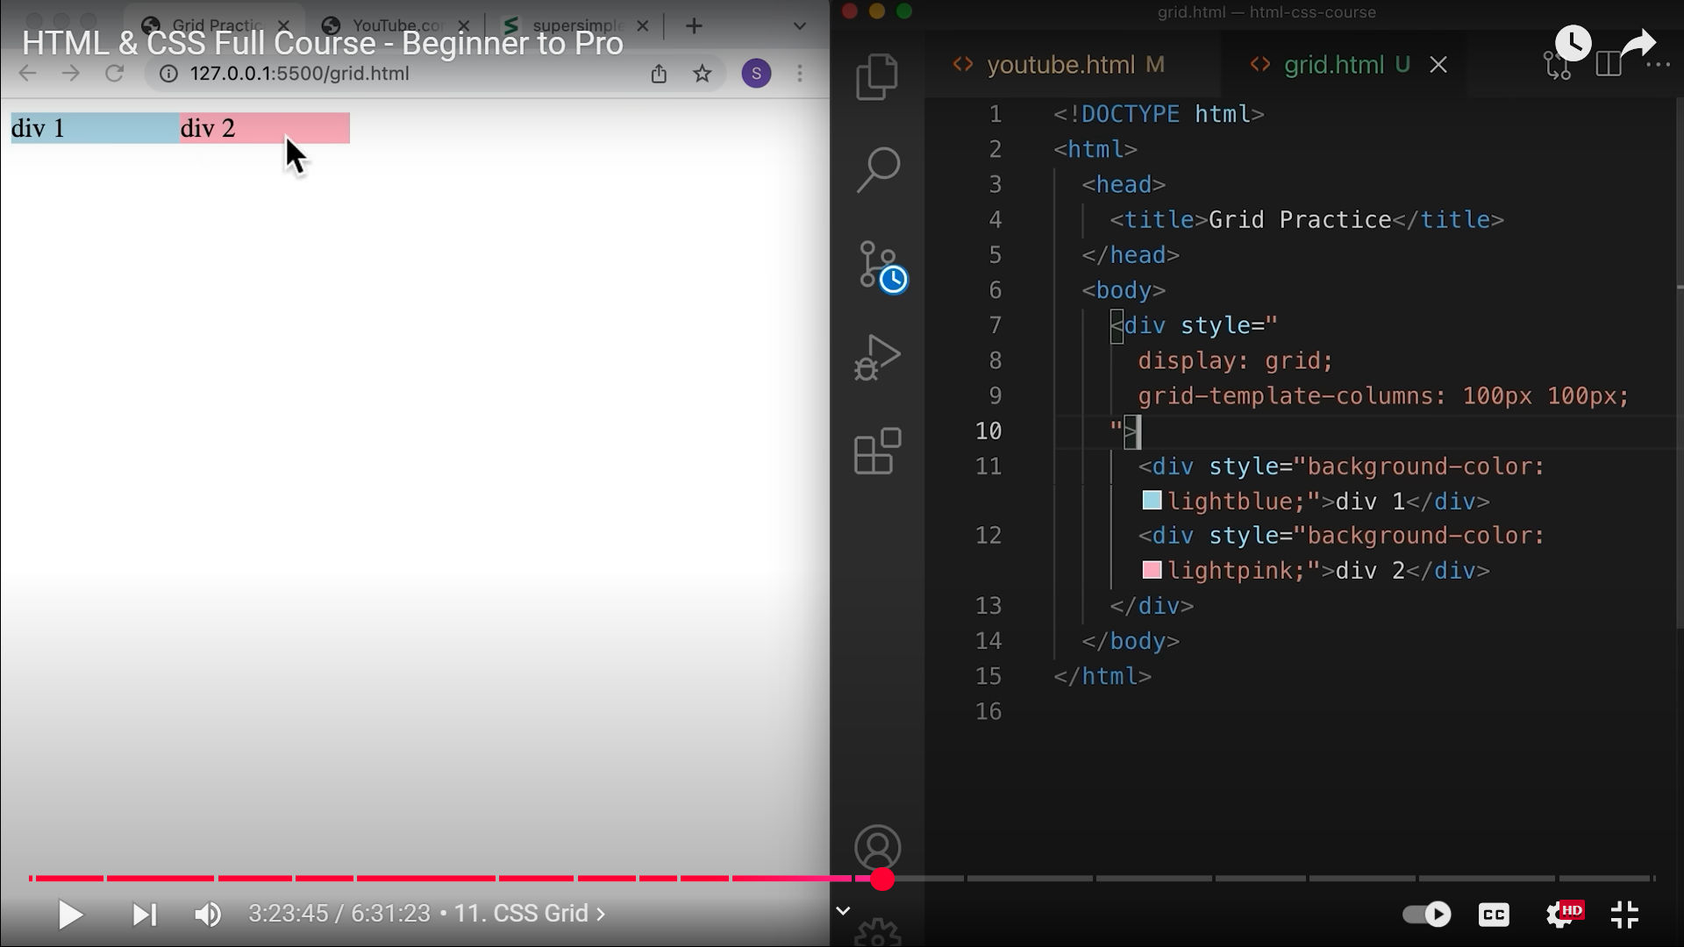 THERE IS NO EXTRA SPACE BETWEEN THE TWO COLUMNS IN GRID UNLIKE INLINE-BLOCK!!!!!!!!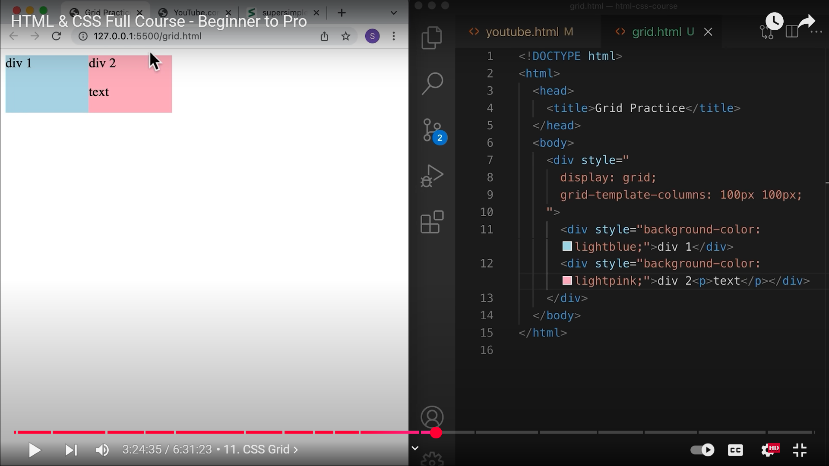 GRIDS ARE ALSO VERTICALLY ALIGNED!!!!!!!!!!!!!!**

**GRID MAINTAINS ALIGNMENT MUCH BETTER!!!!!!!!!!!!!!!!!!!!!!!!!!!!!**

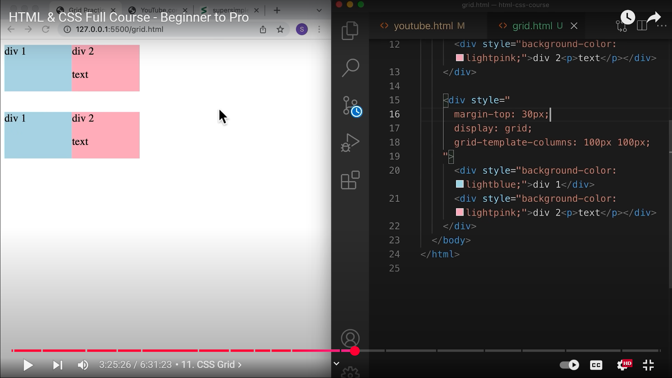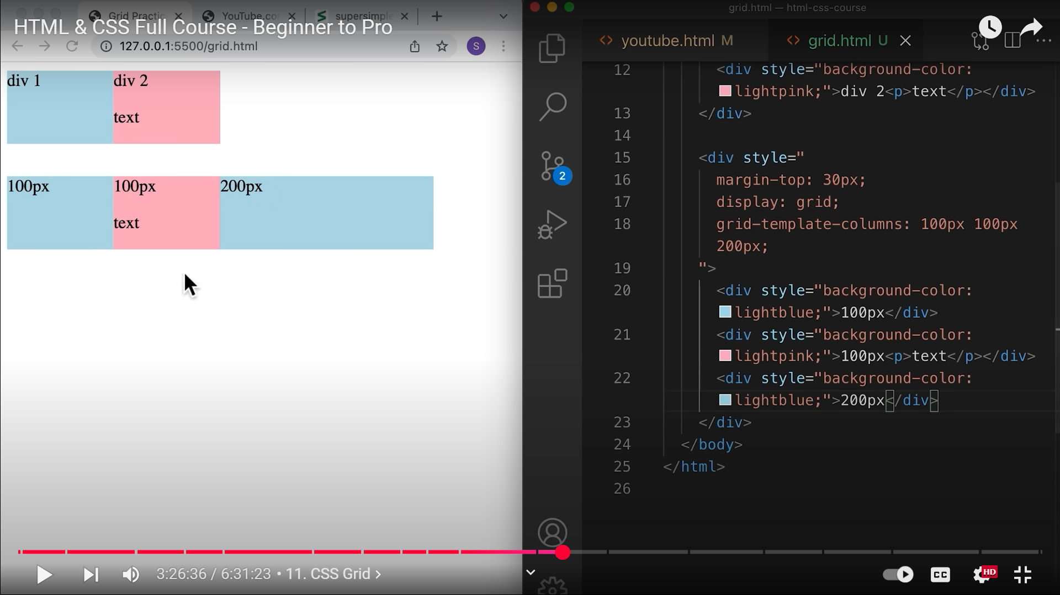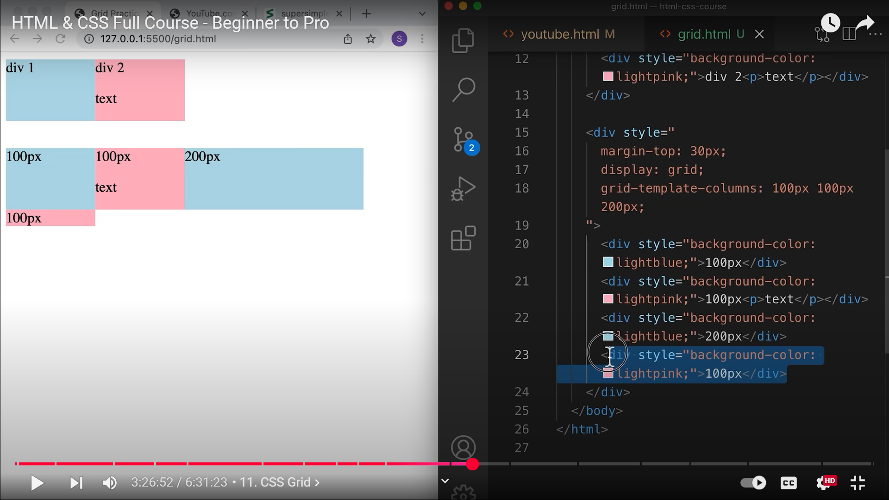 **4TH DIV IS GETTING WRAPPED ON TO THE NEXT ROW**

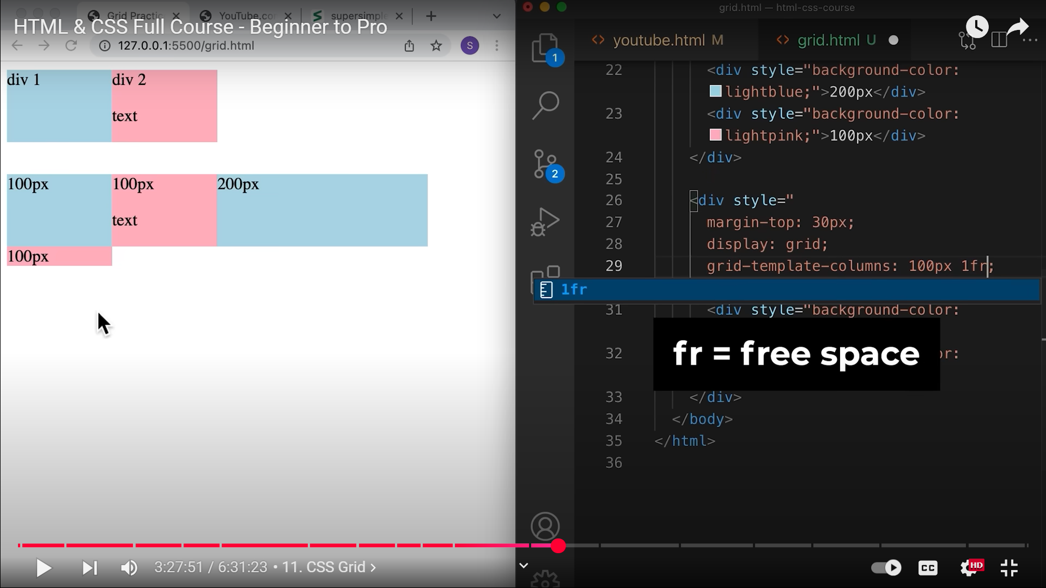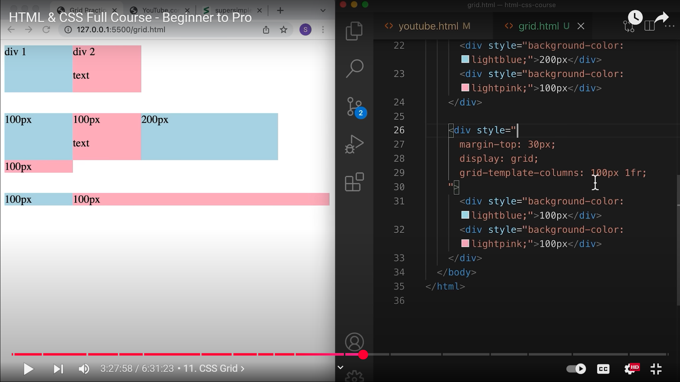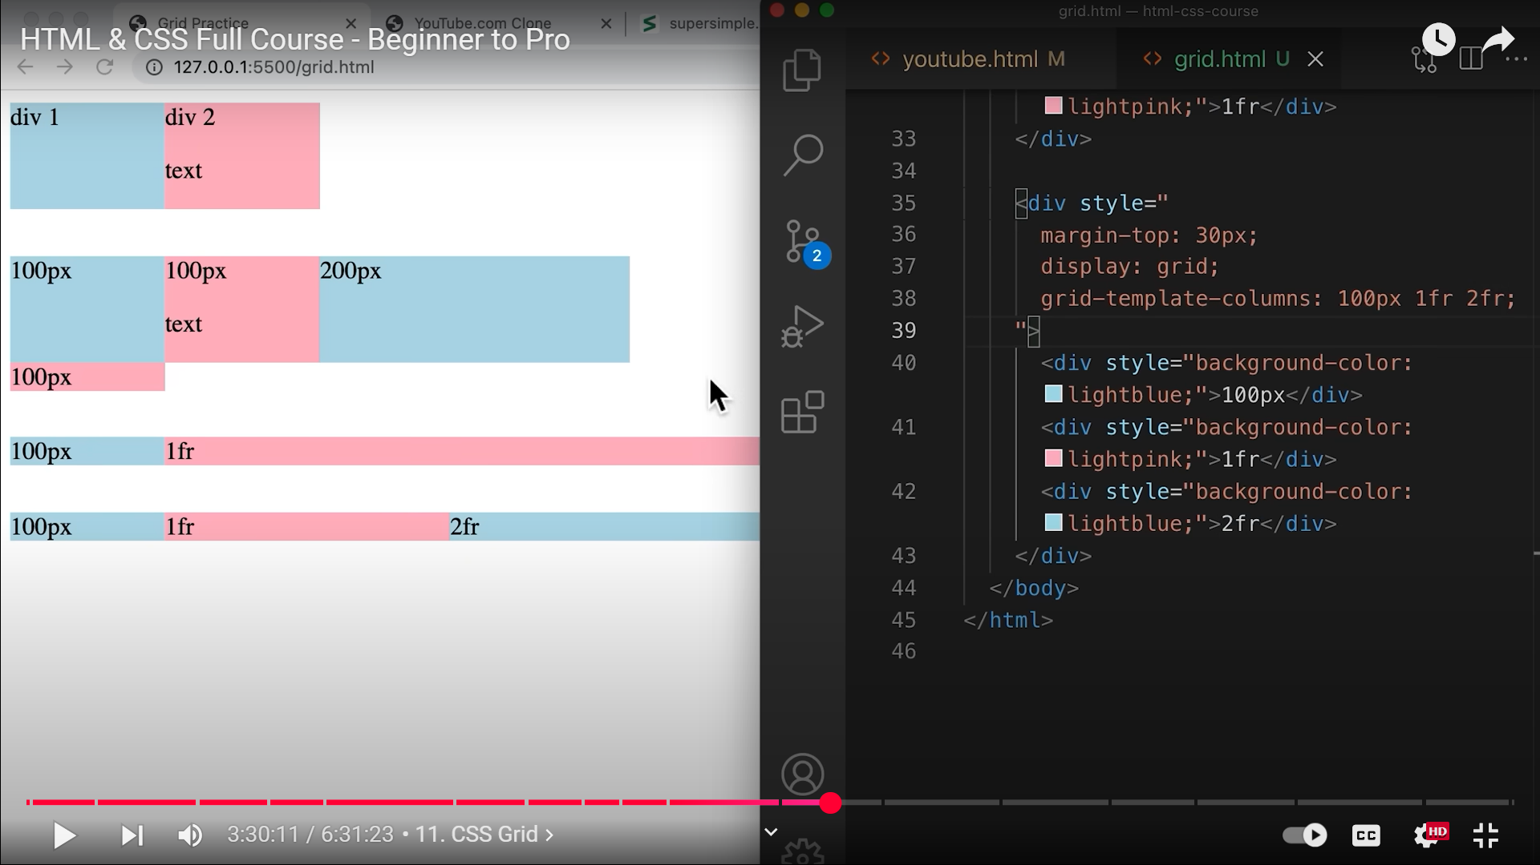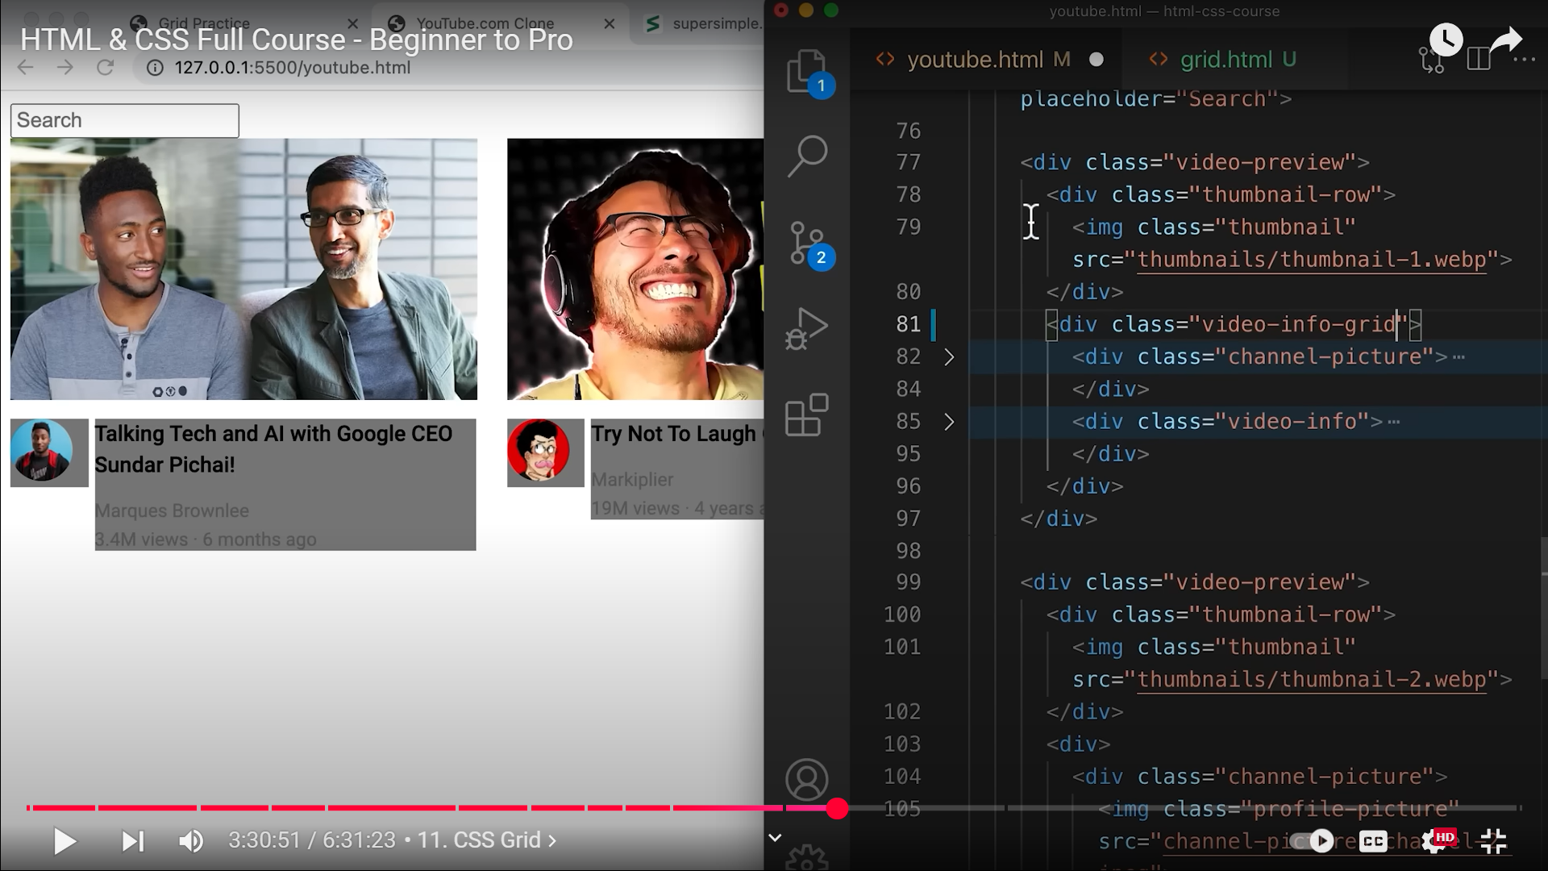Adding class at 81 which is the grid container  
  
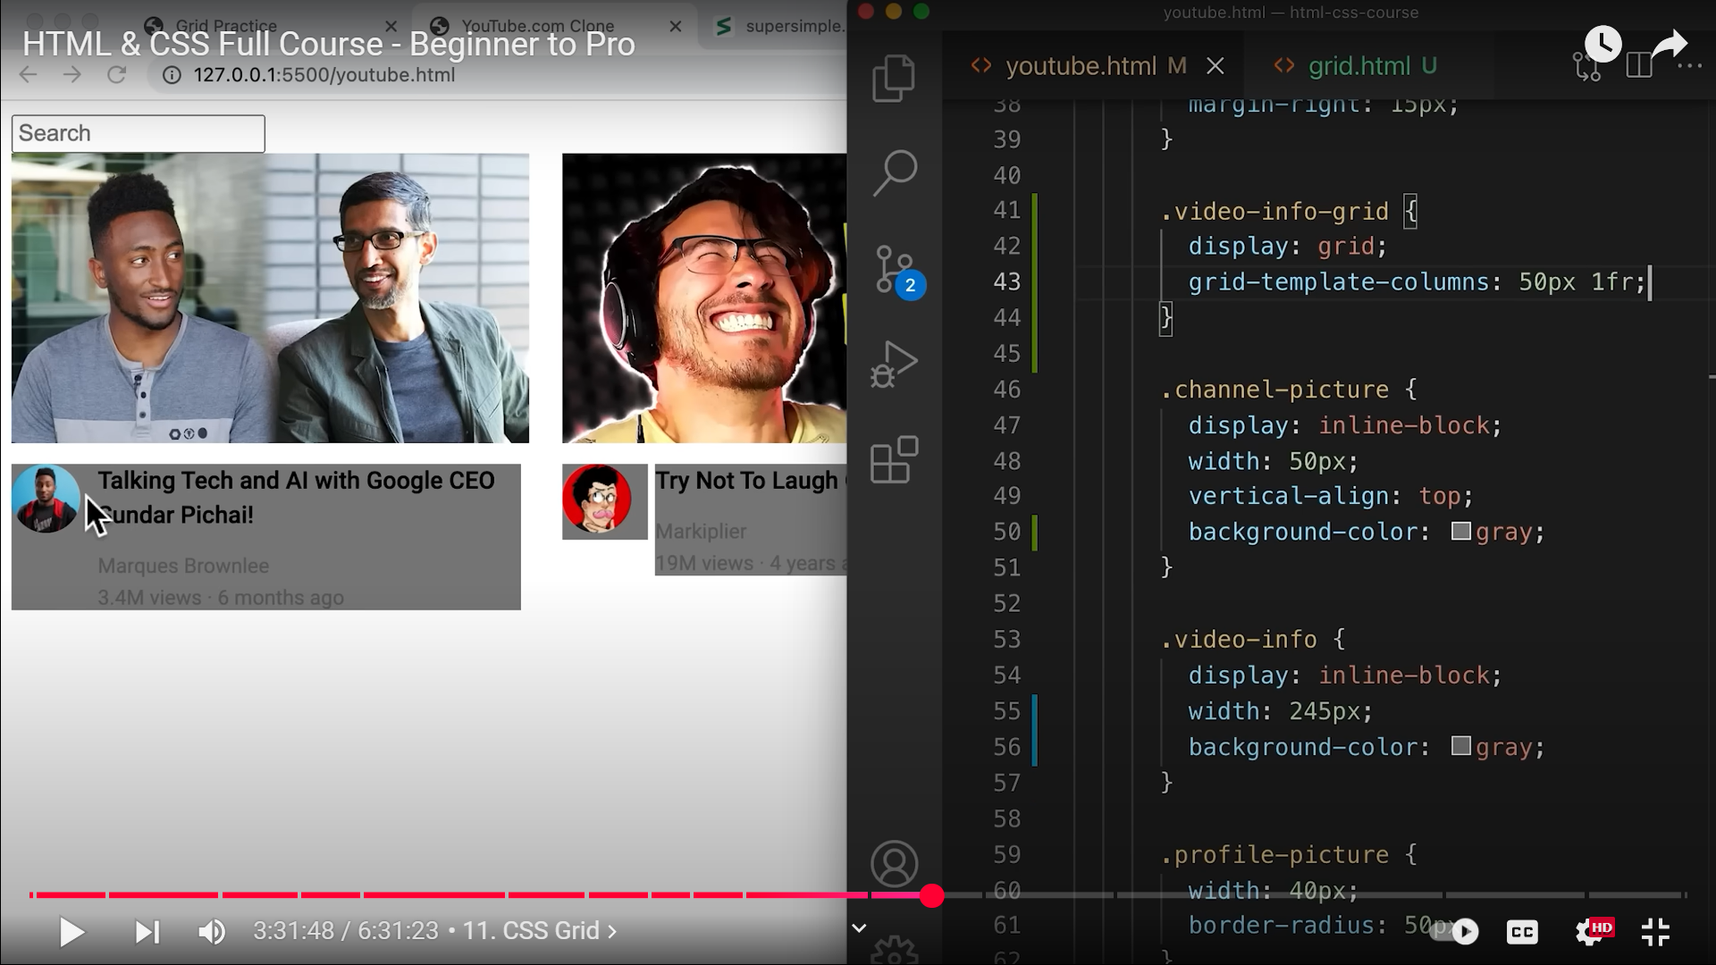  
41  
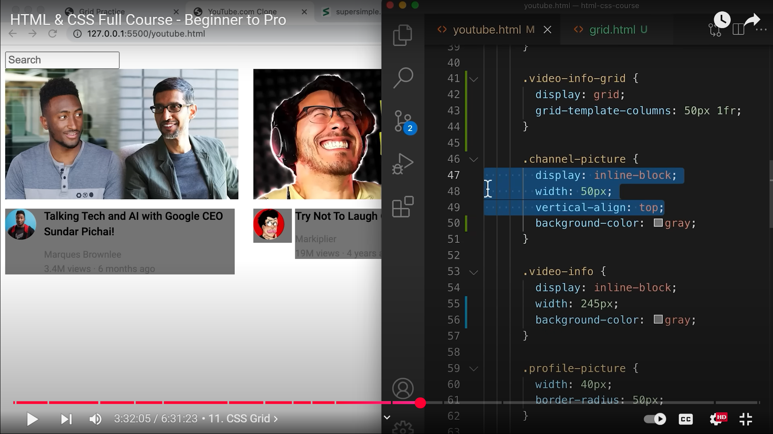  
**NOW THAT WE HAVE GRIDS, INLINE-BLOCKS CAN BE REMOVED!!!!!!!!!!!!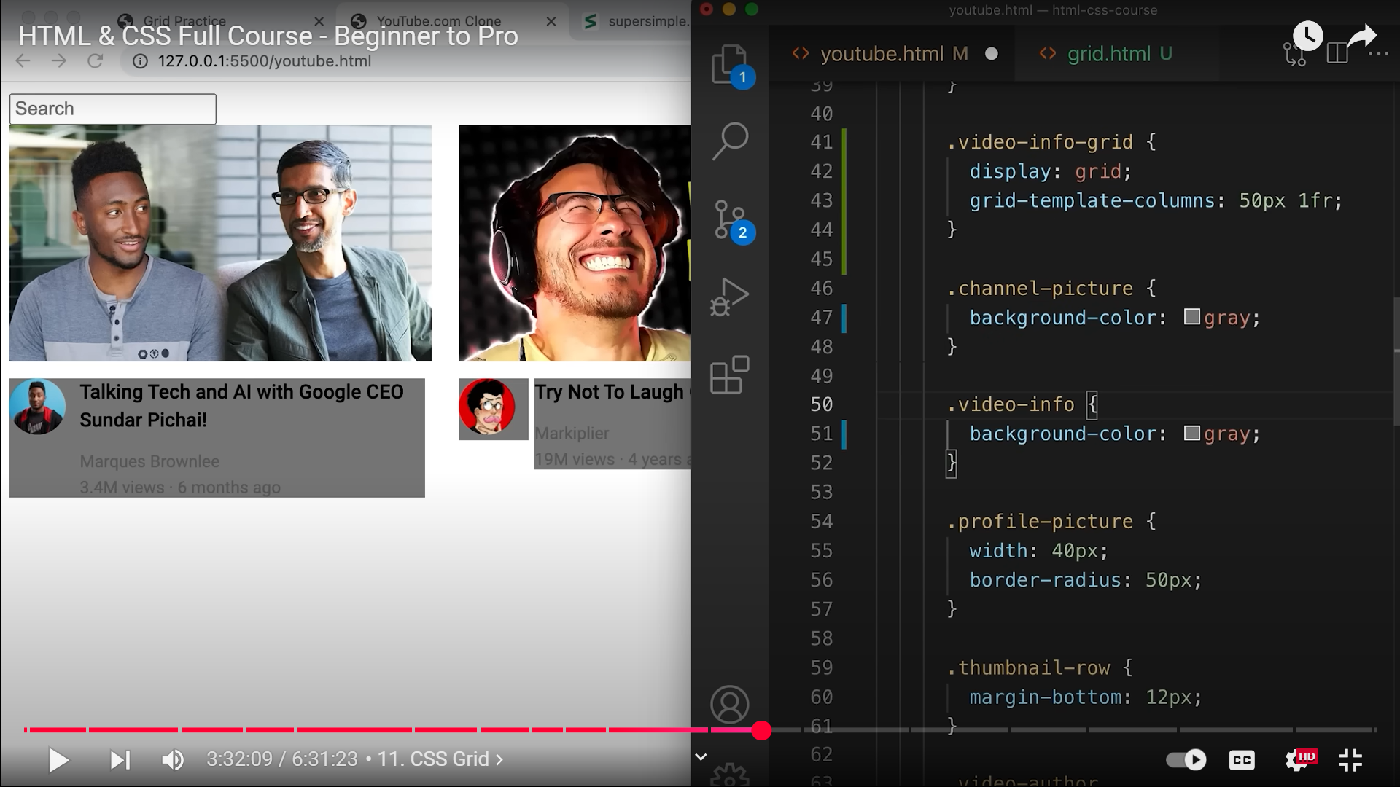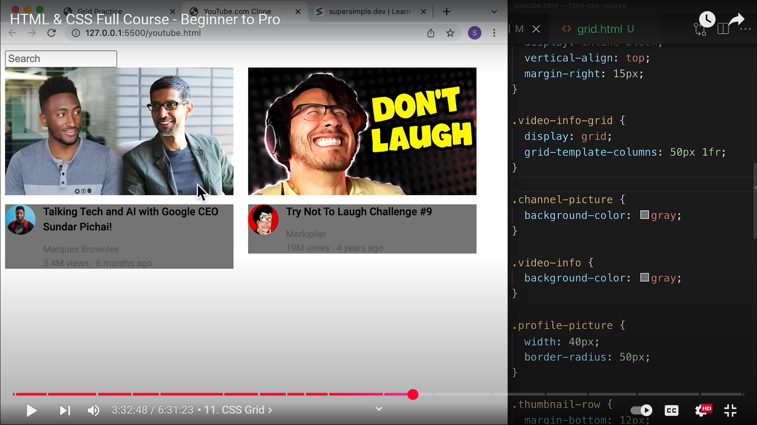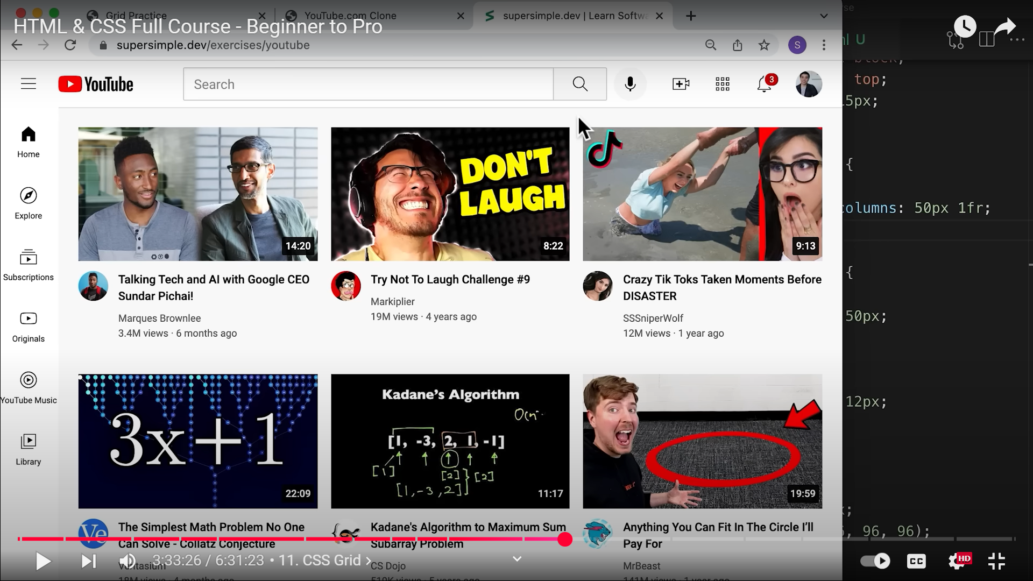 NOW LETS PRACTICE THE BIGGER GRID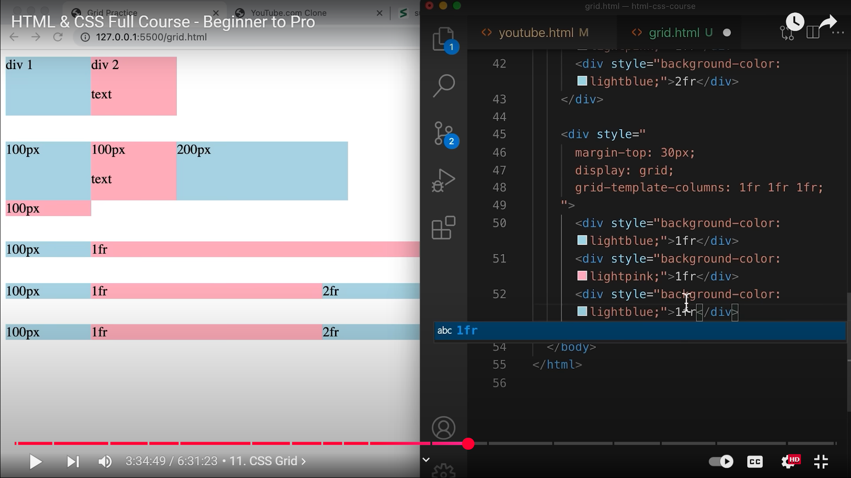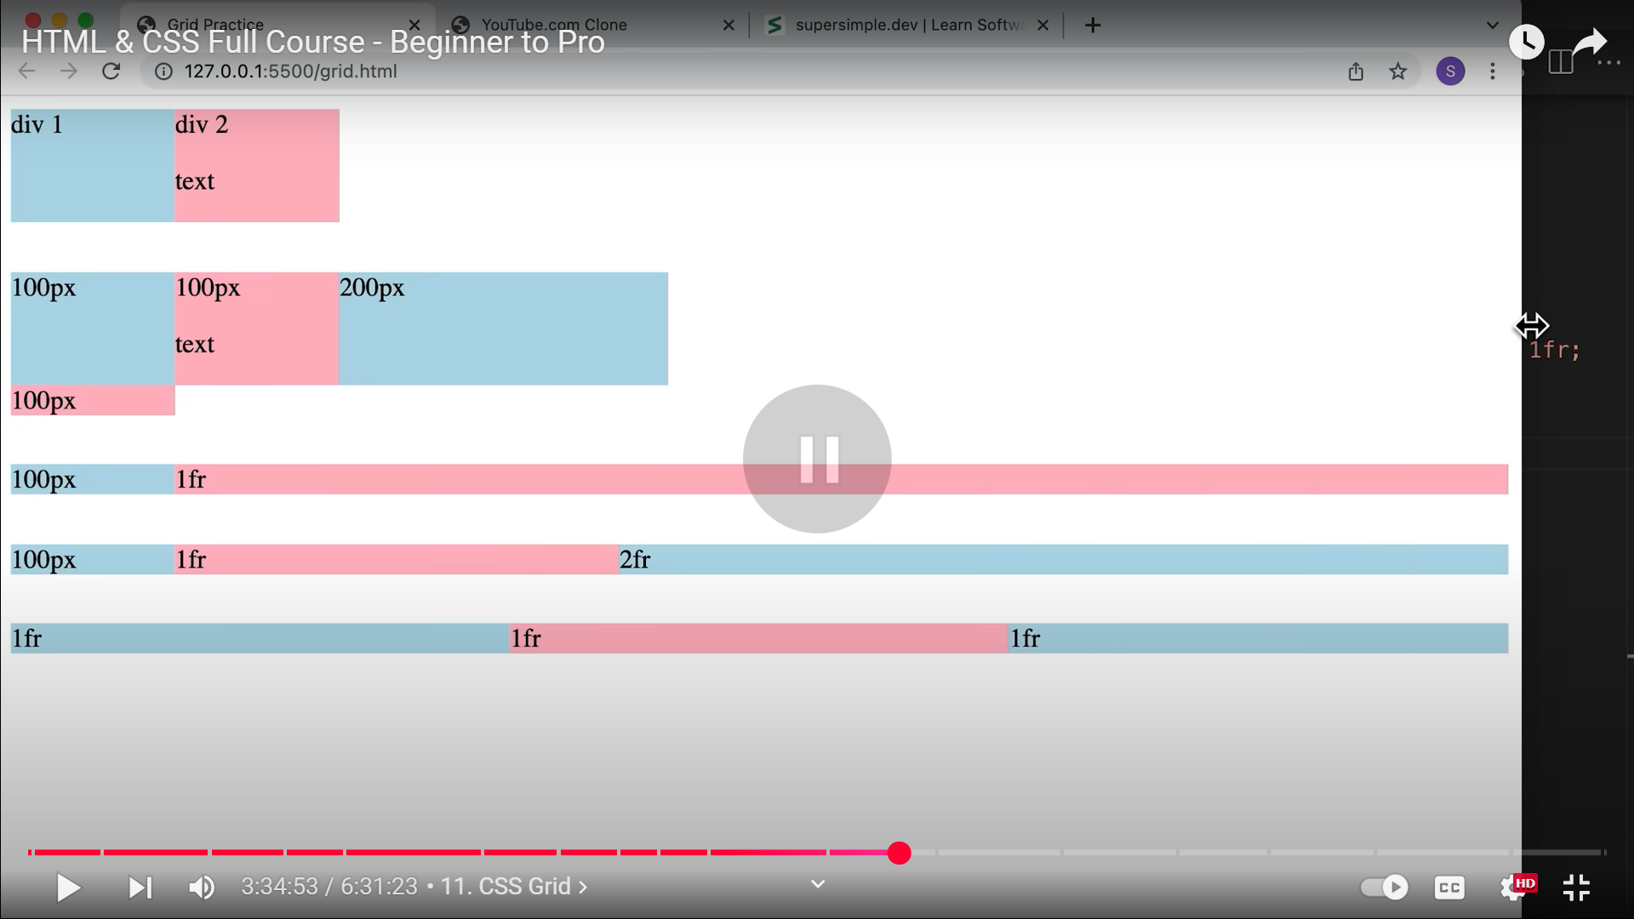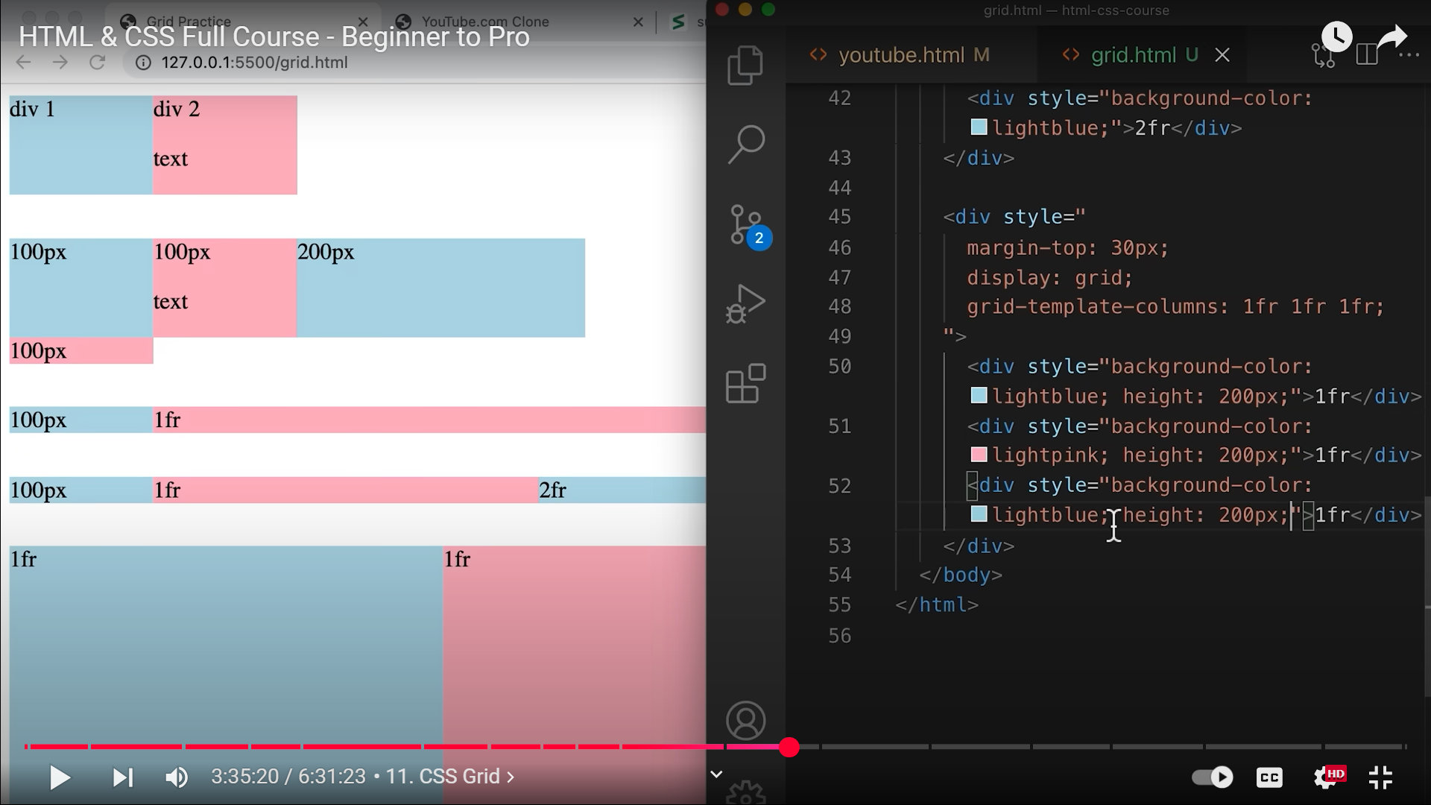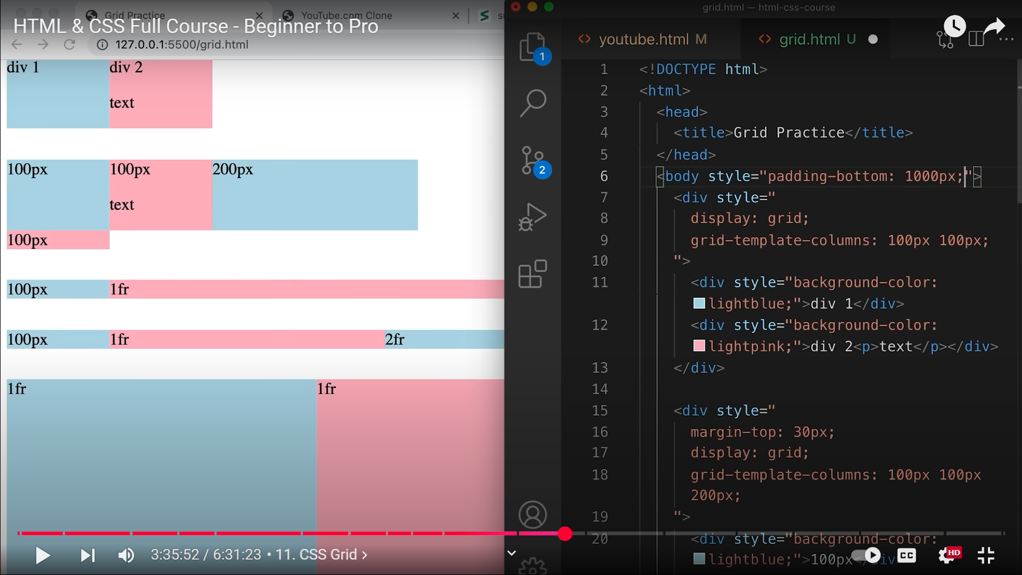 6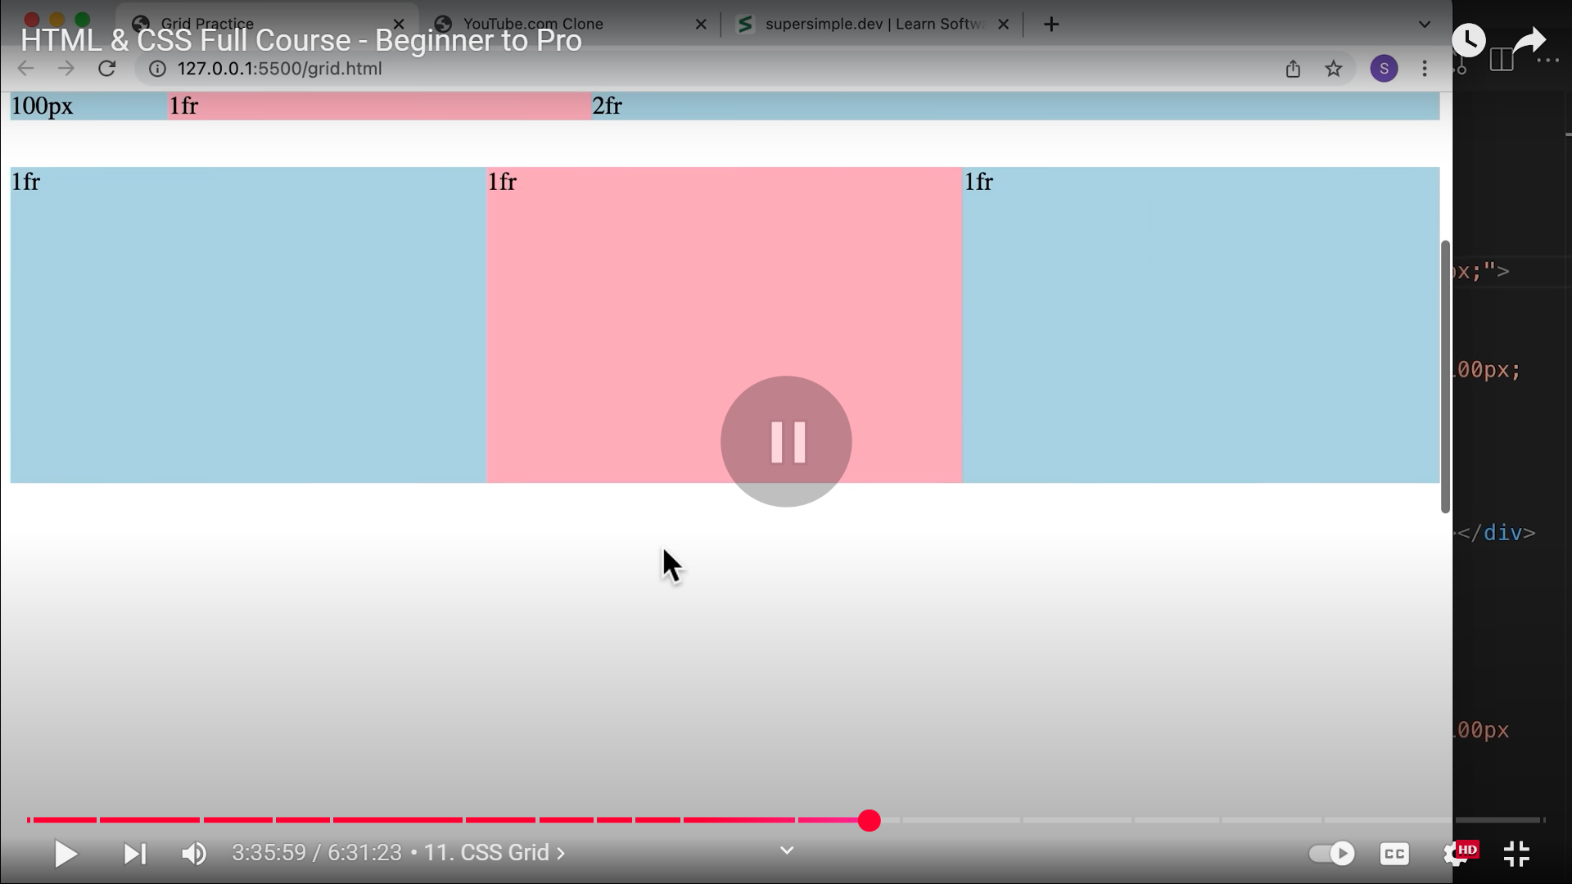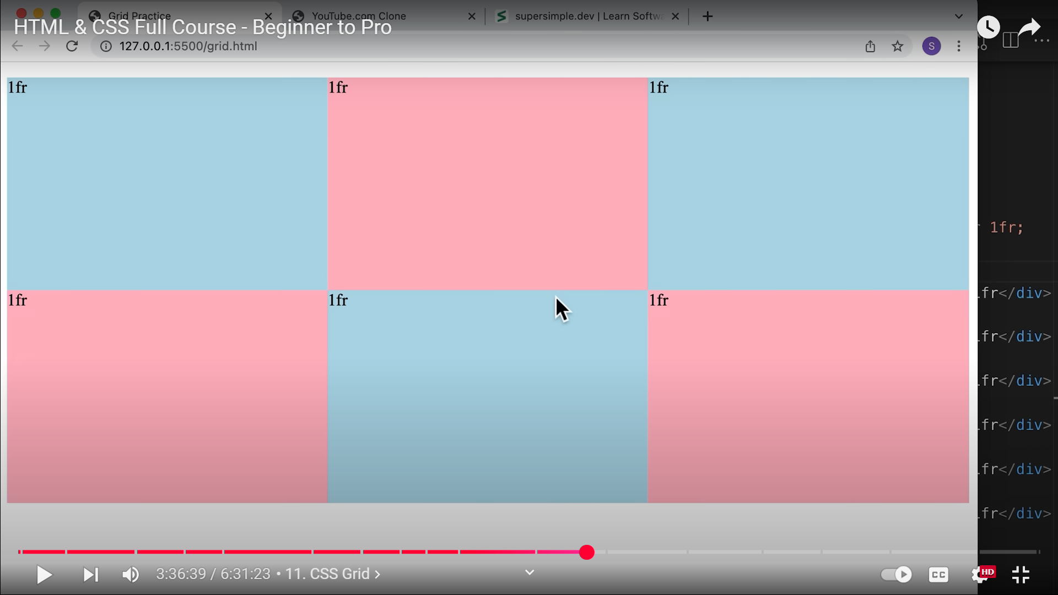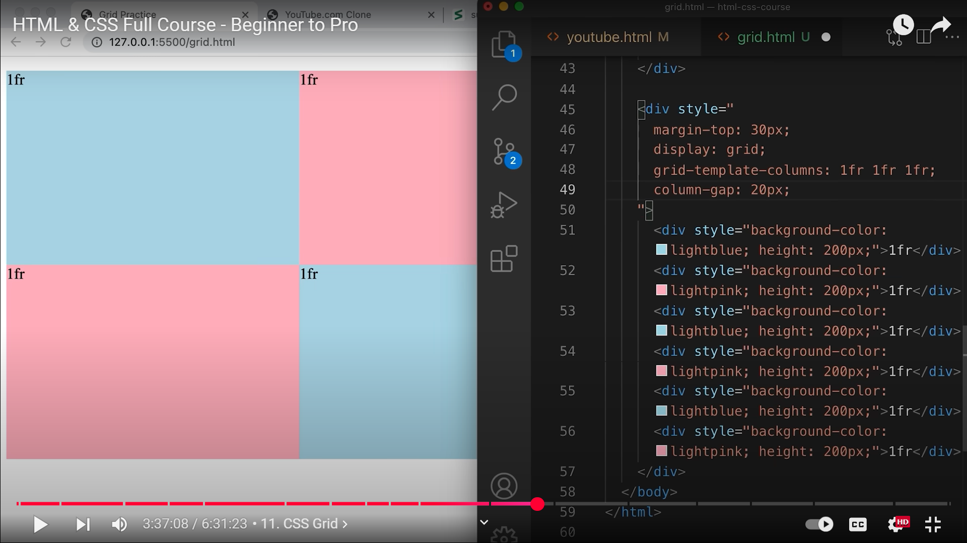 49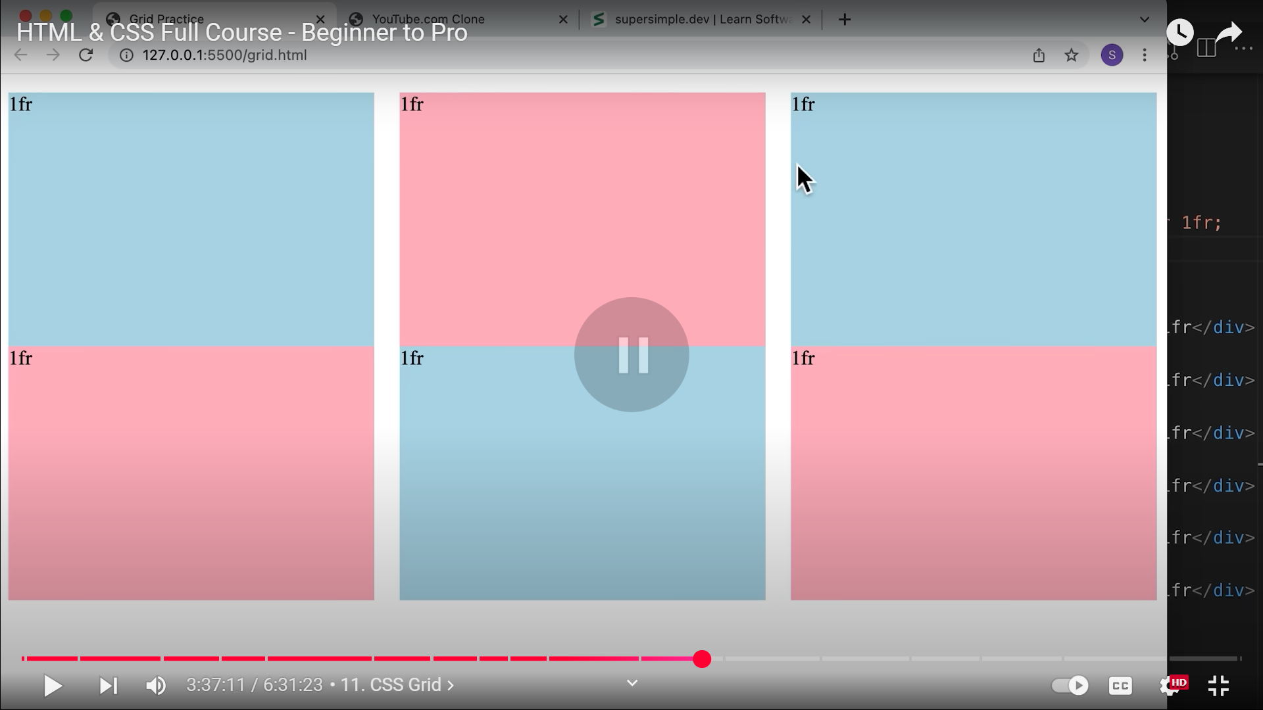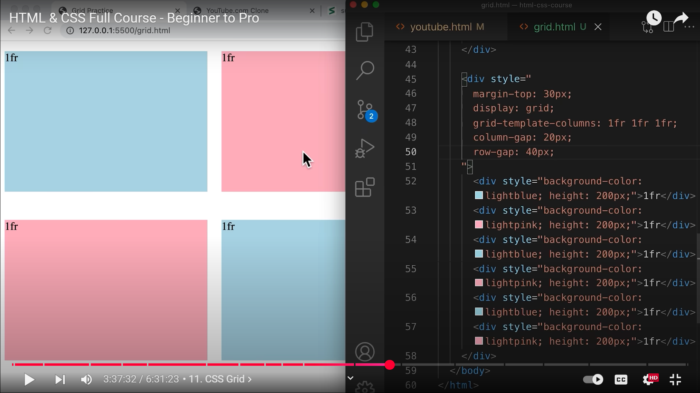 50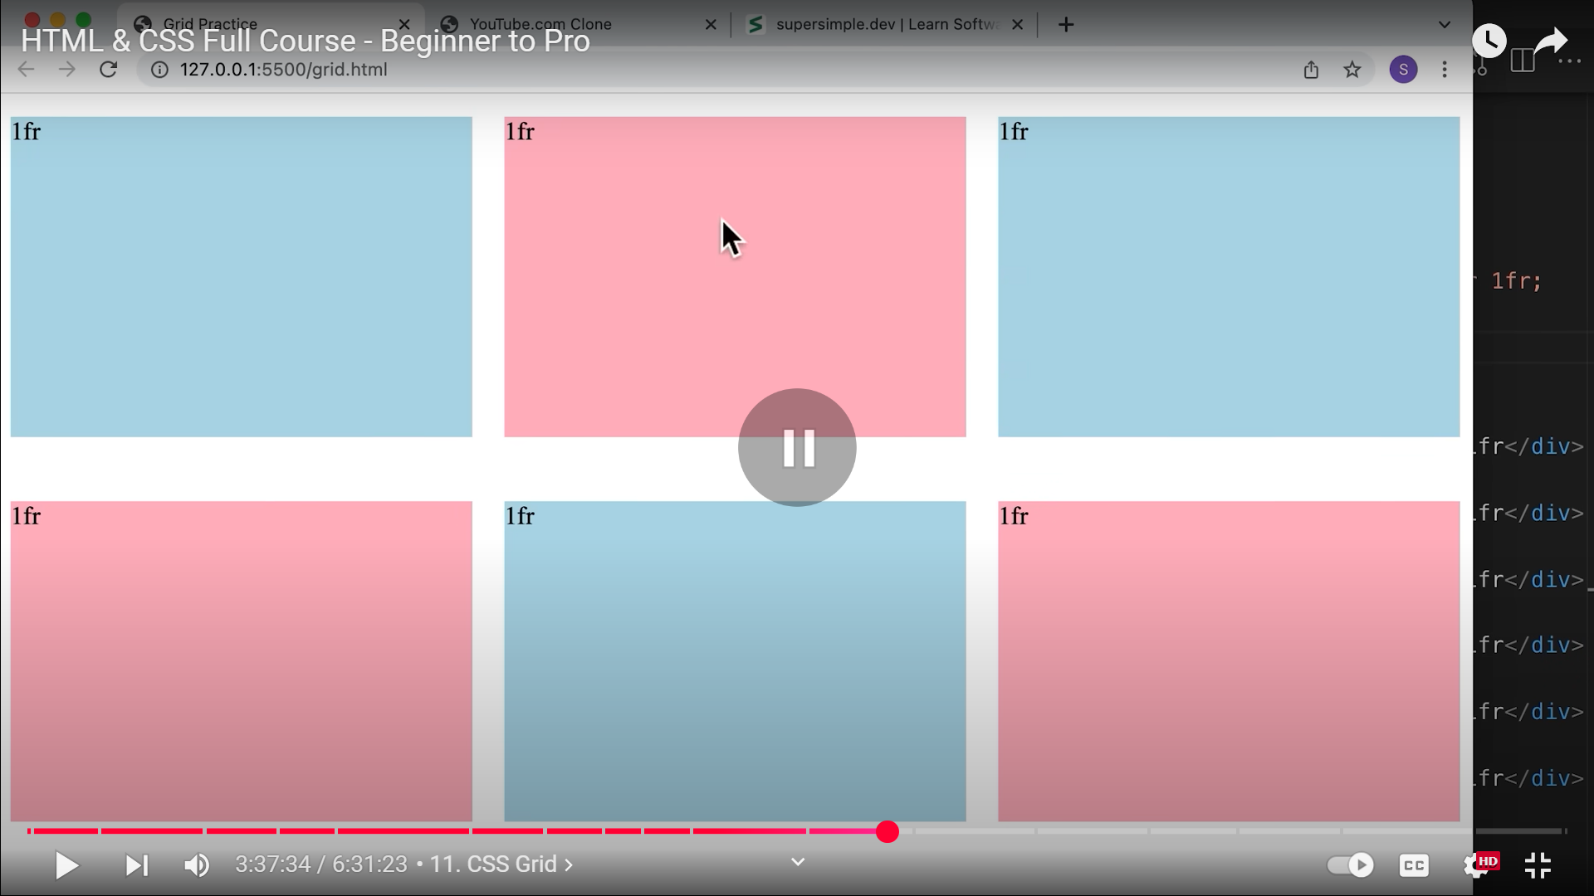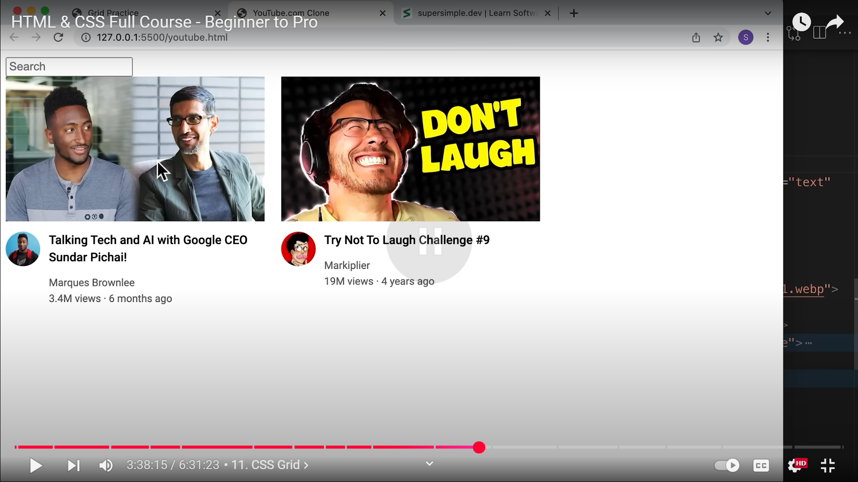 NOW LETS CREATE 6 OF THESE VIDEO PREVIEWS TO ORGANIZE THEM INTO GRID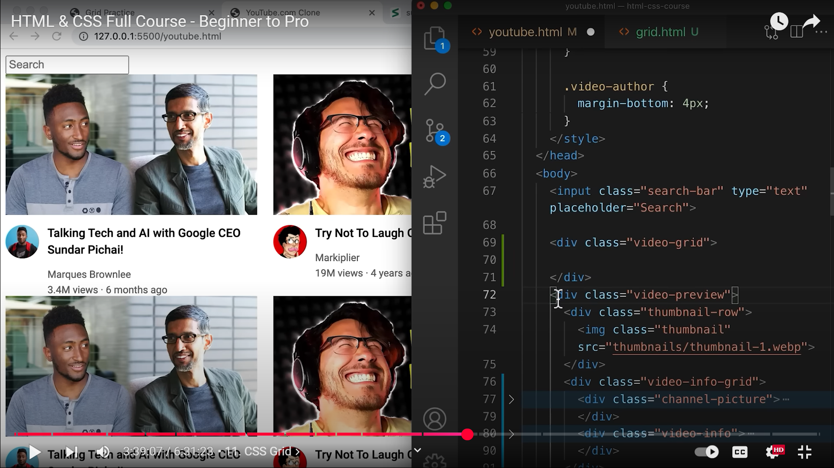 69, GRID CONTAINER FOR ALL 6 VIDEO PREVIEWS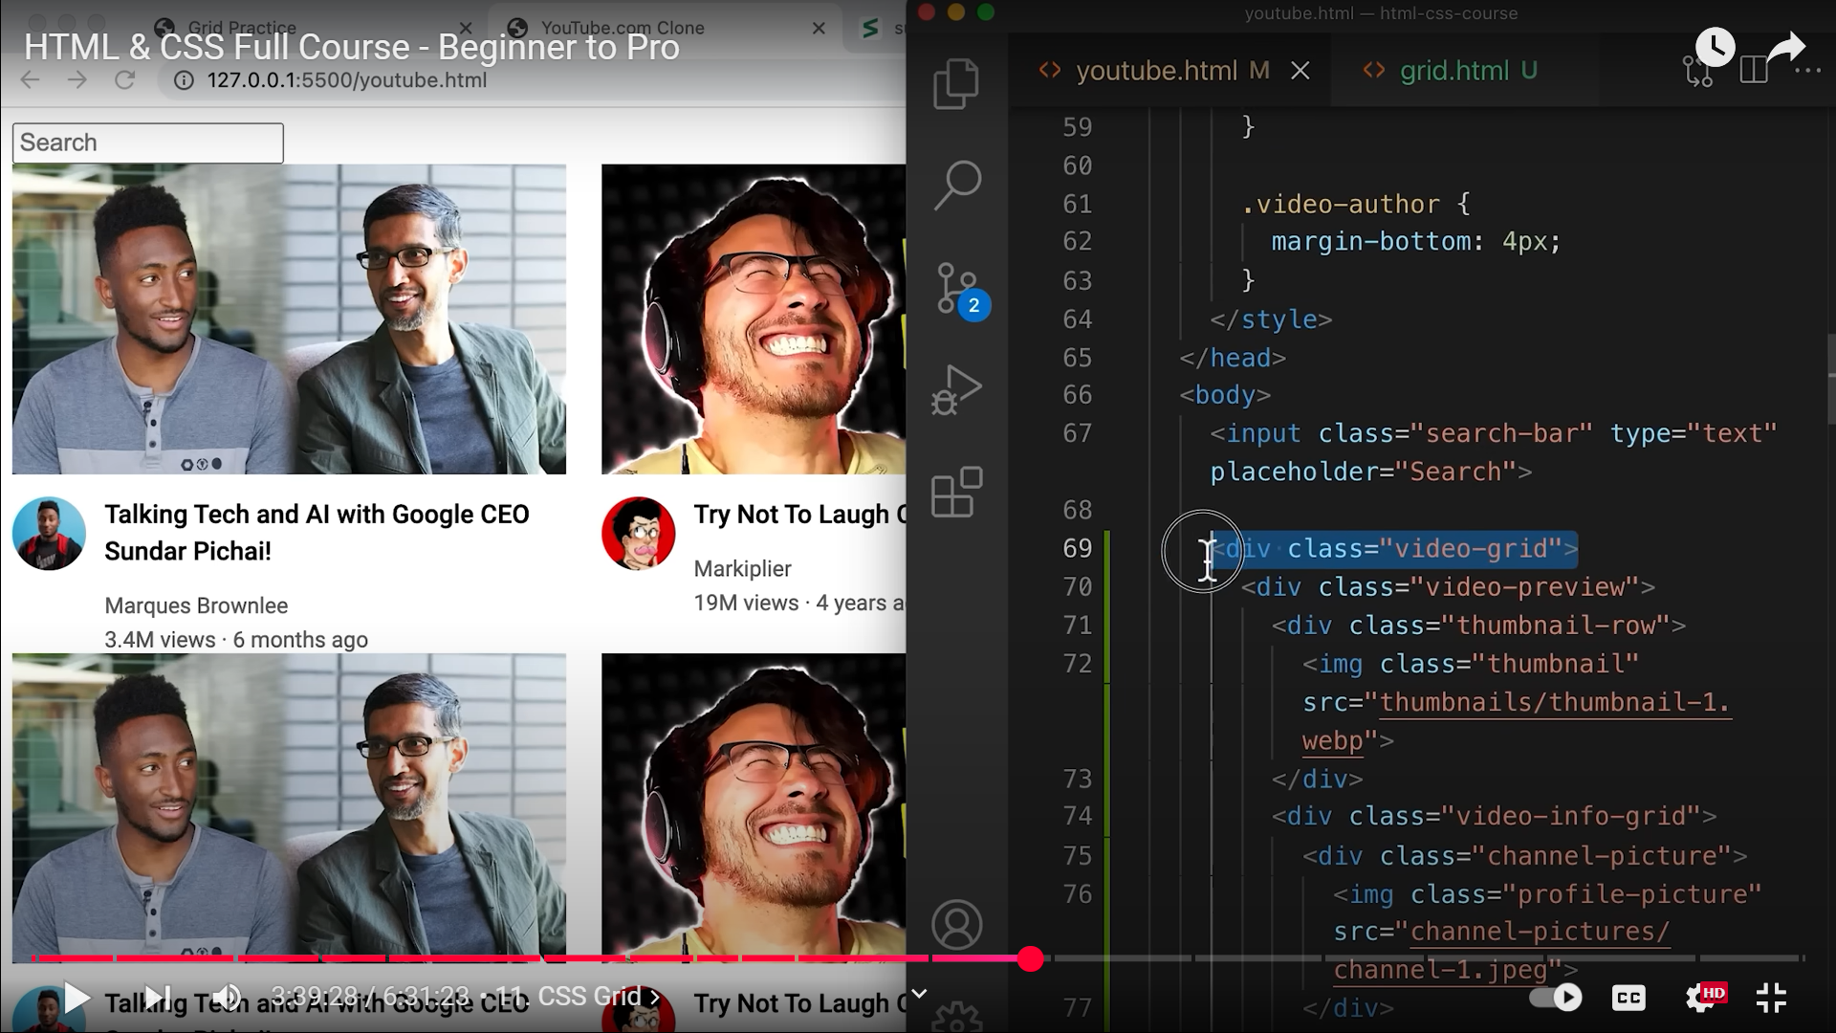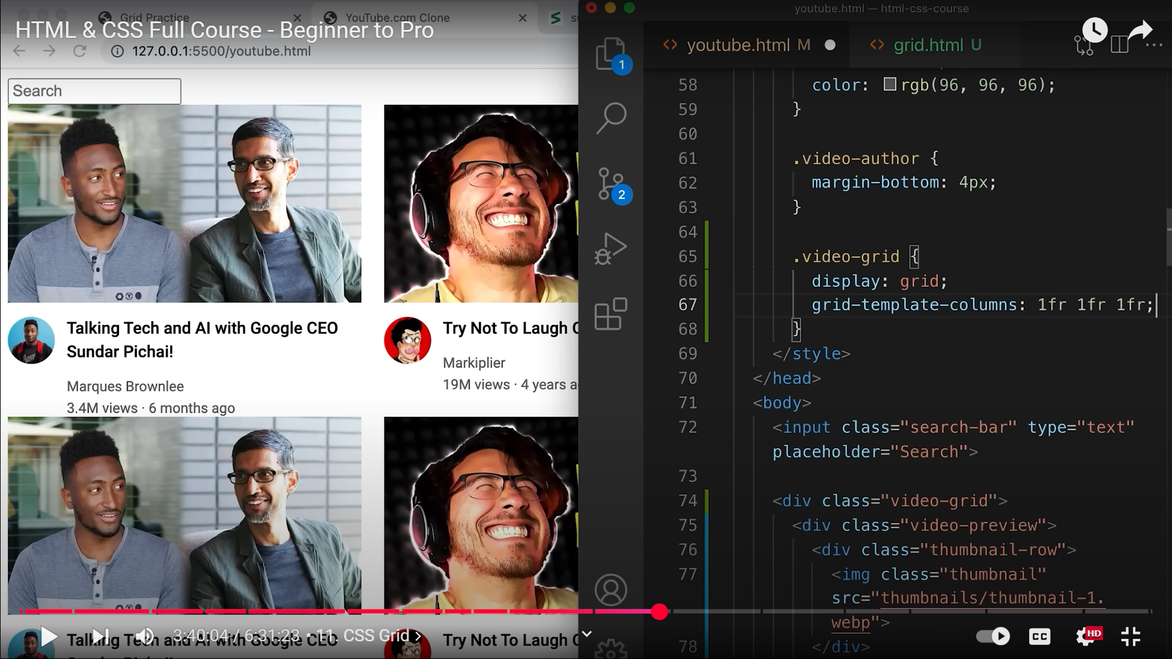 65** **NOW THE ISSUE IS THAT THE GRID IS NOT RESIZING EVEN AFTER USING 1FR 1FR 1FR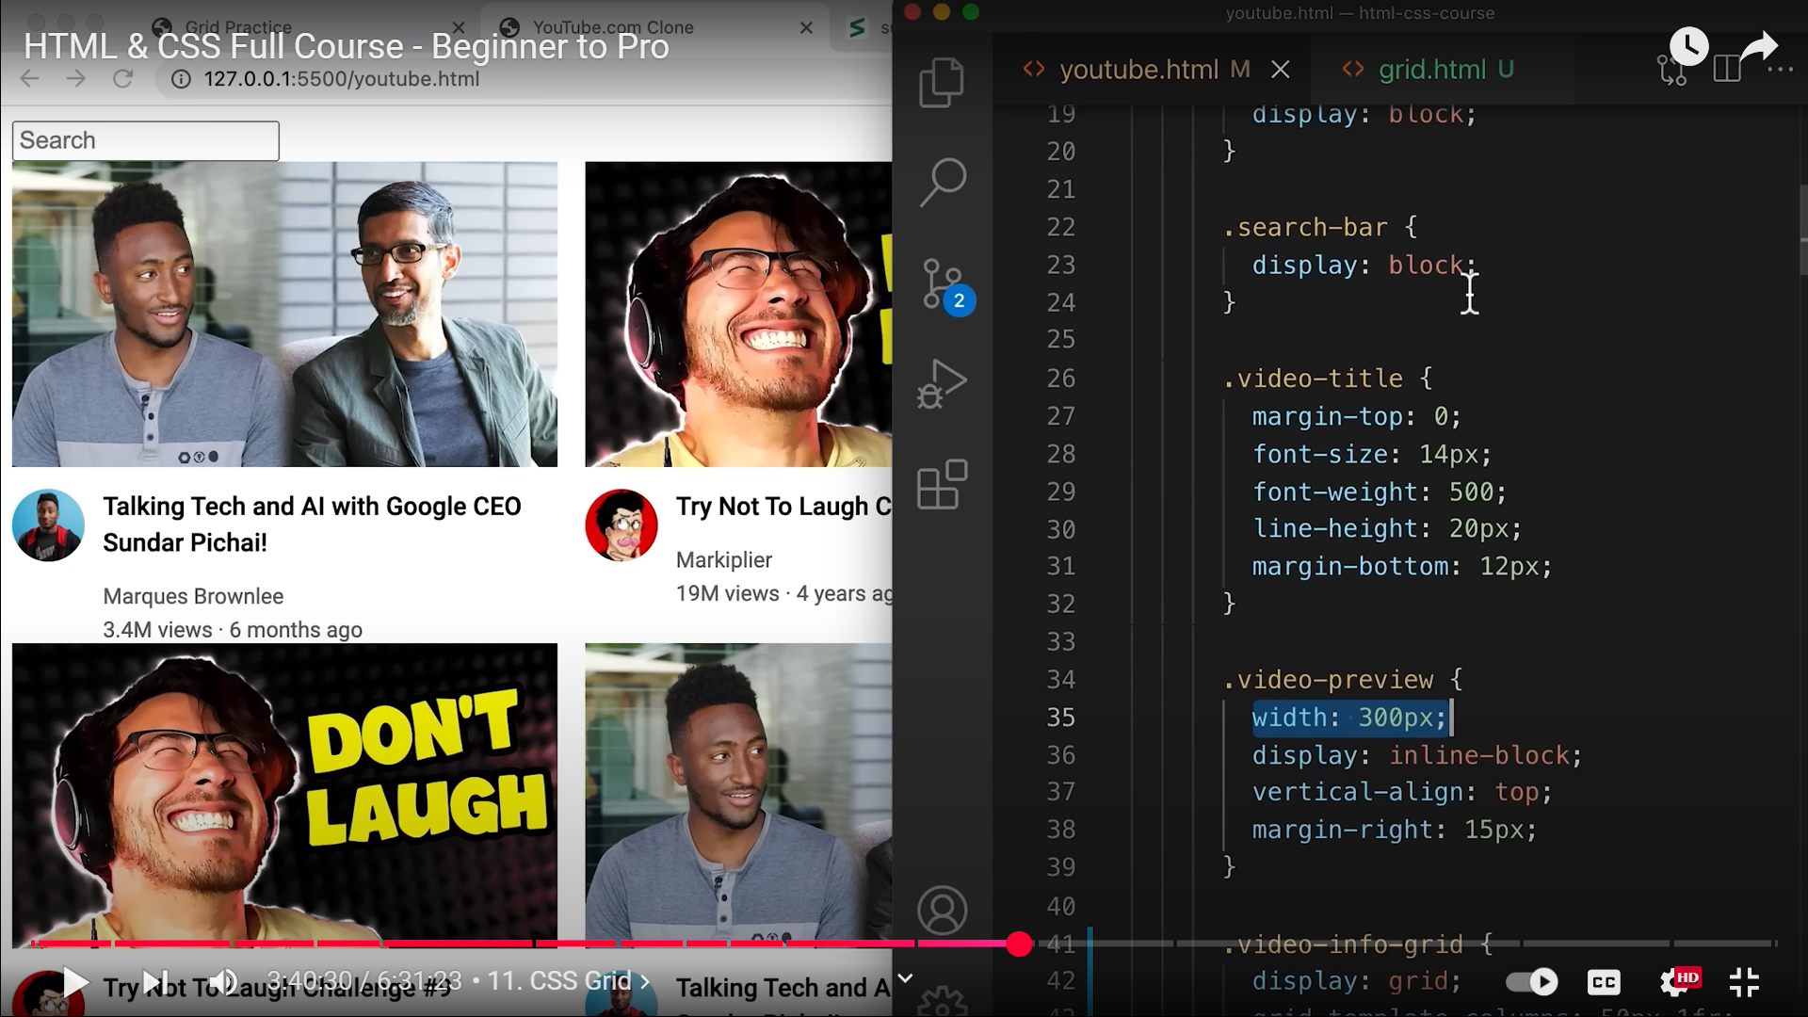 THIS RESIZING ISSUE IS DUE TO THE WIDTH SPECIFIED AT 35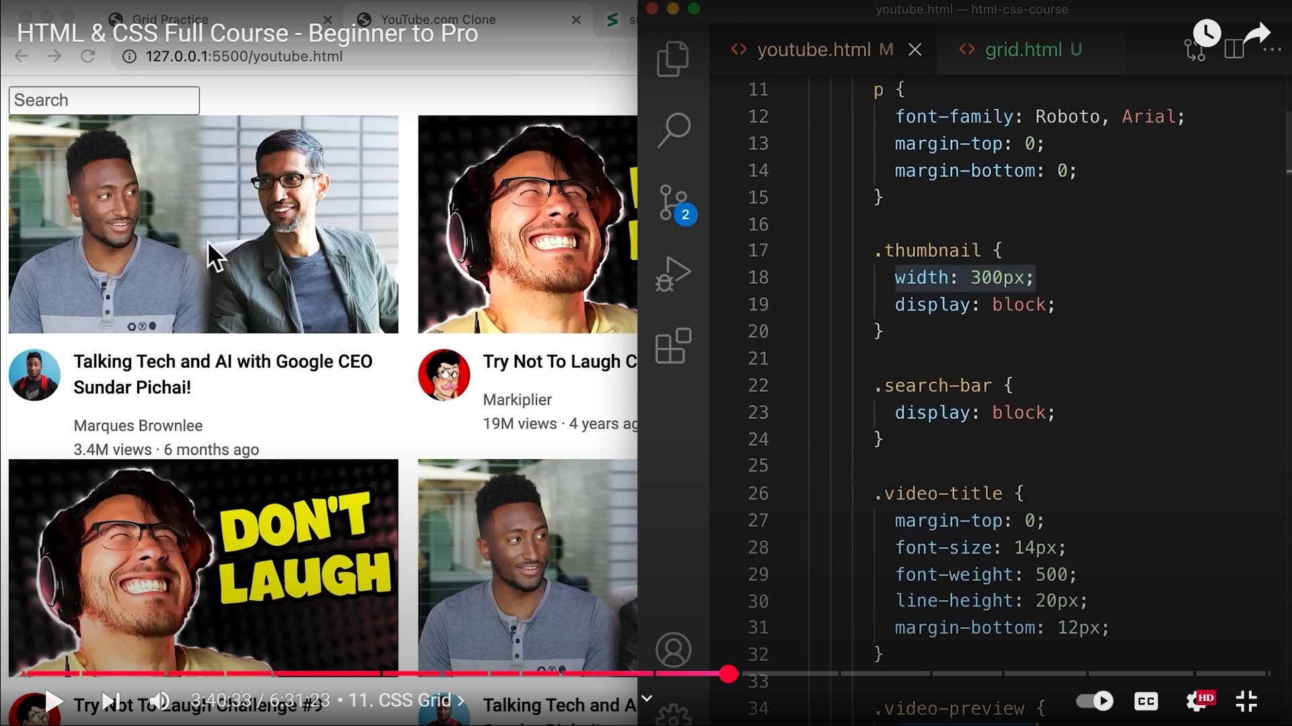 AND ALSO DUE TO 18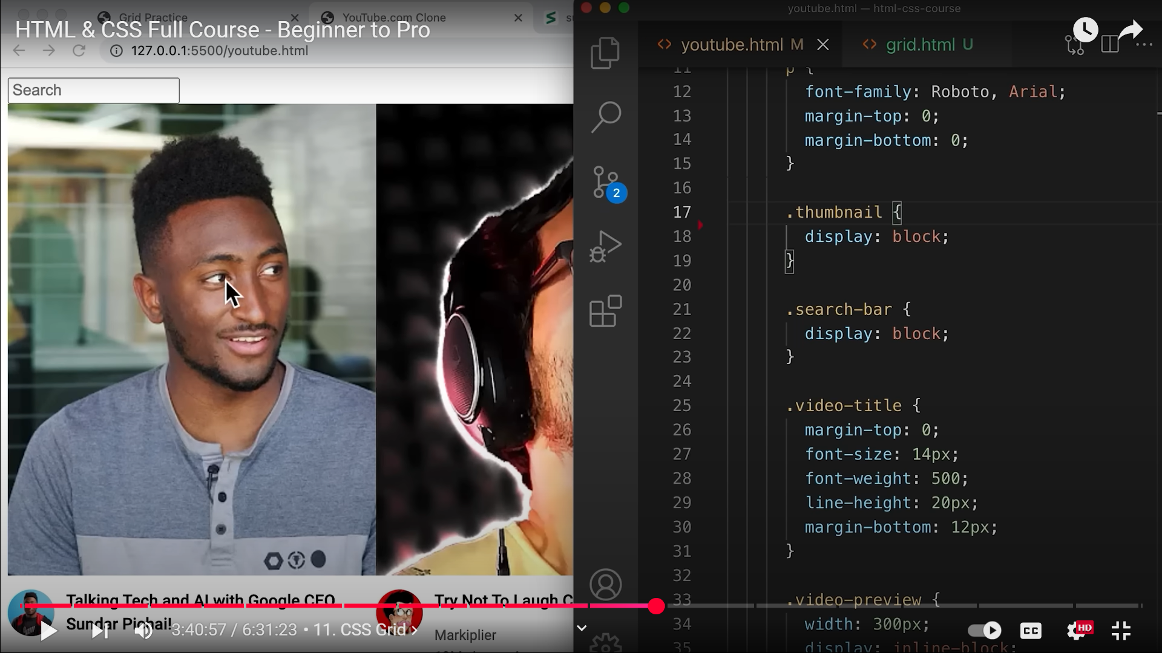 IMAGES ALWAYS KEEP THEIR ORIGINAL SIZE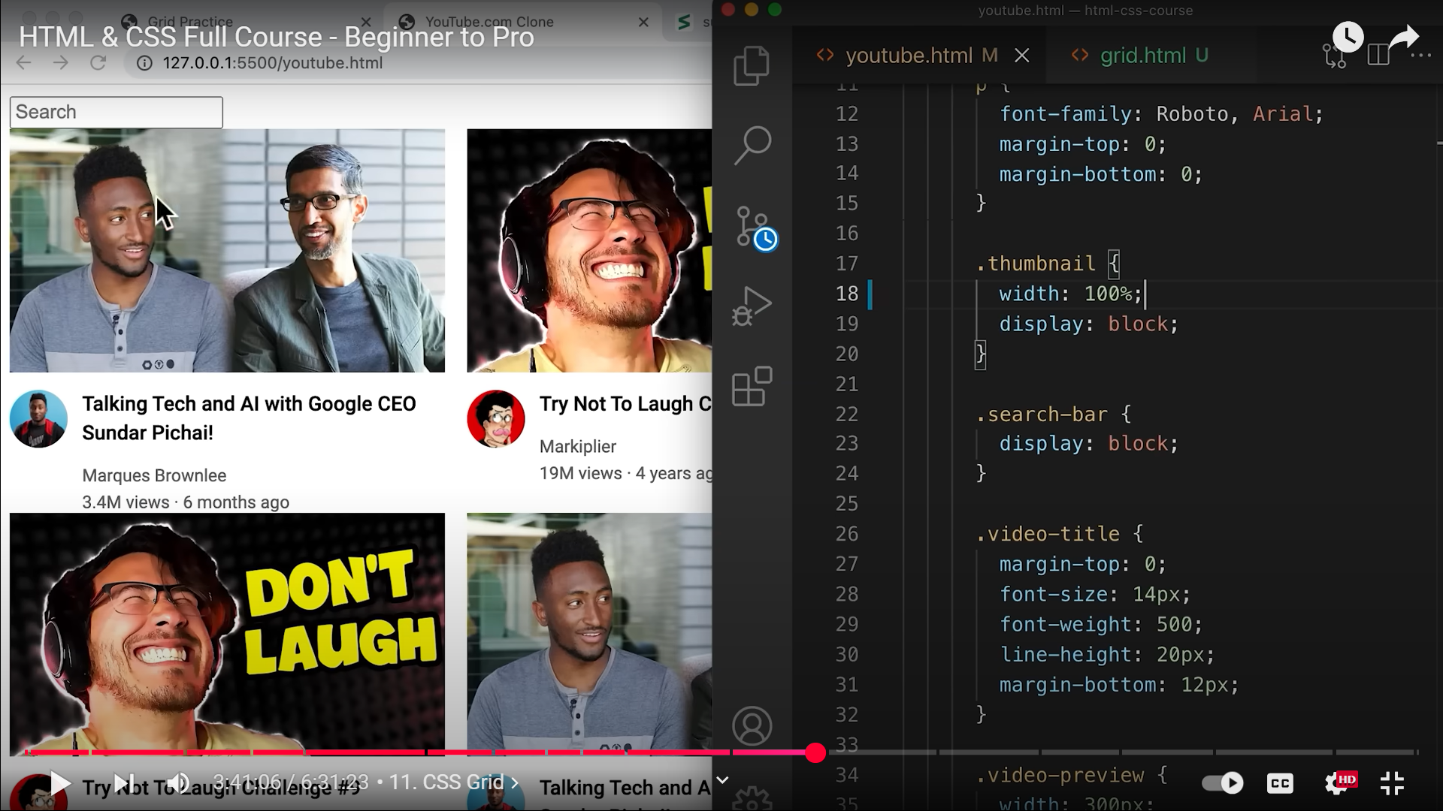 18, NOW THEY TAKE UP ONLY 100% OF THE CONTAINER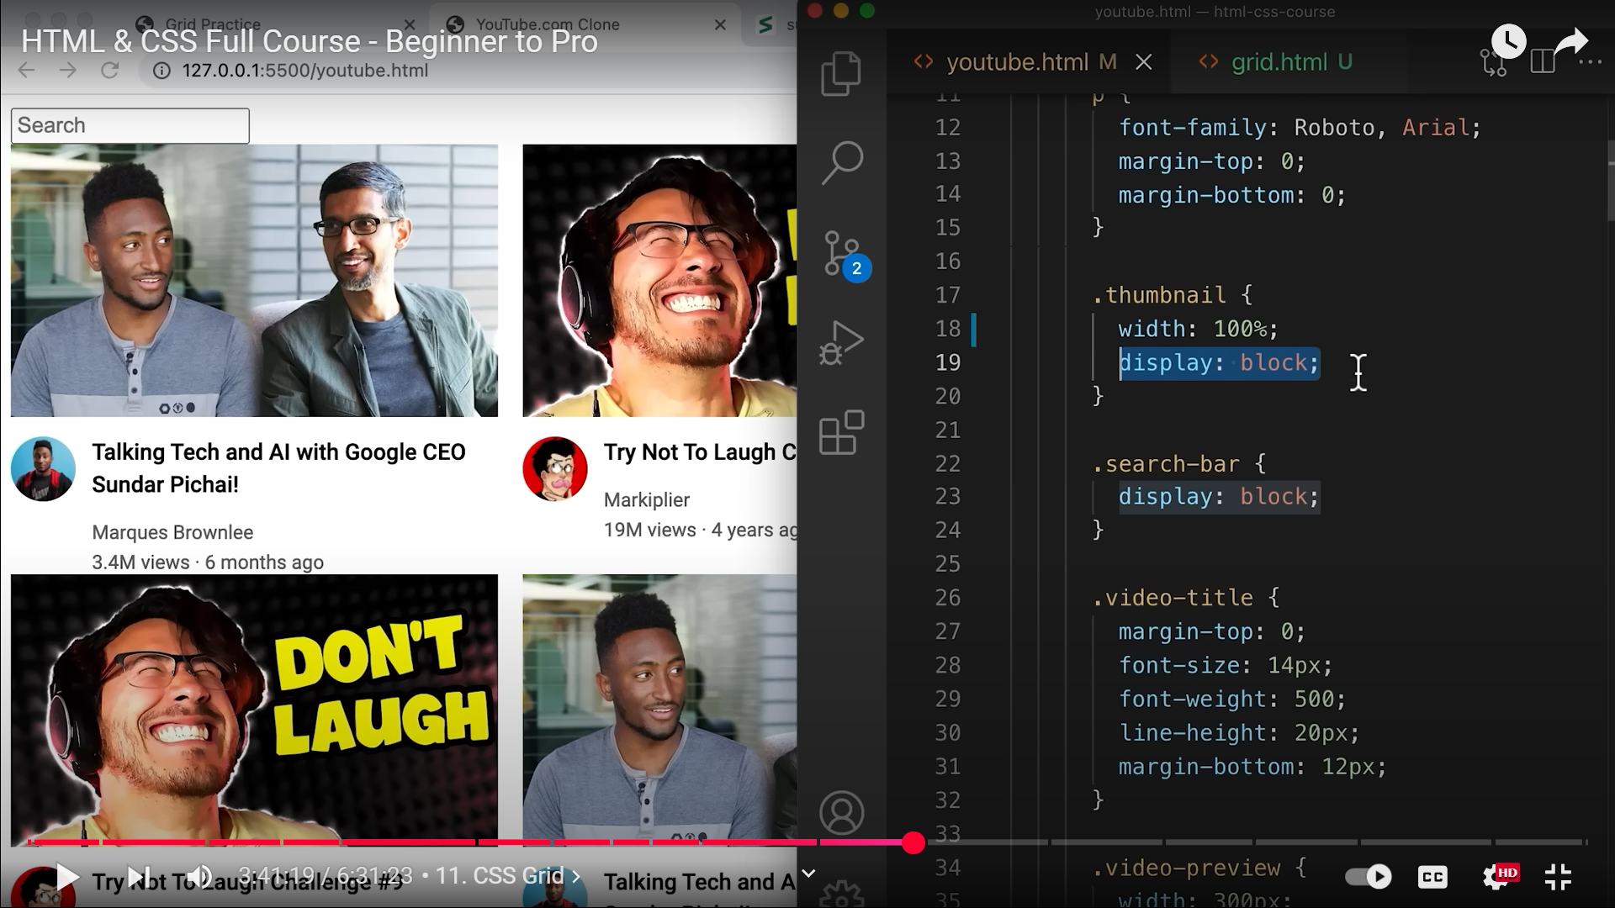 19 CAN BE REMOVED AS THE IMAGE IS ALREADY TAKING 100% OF THE CONTAINER.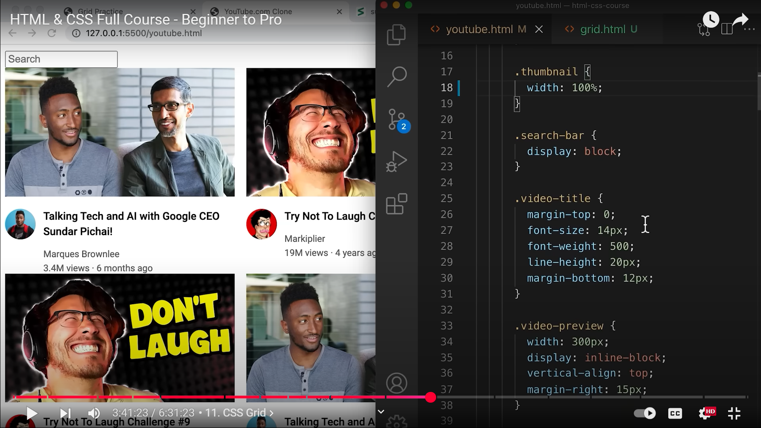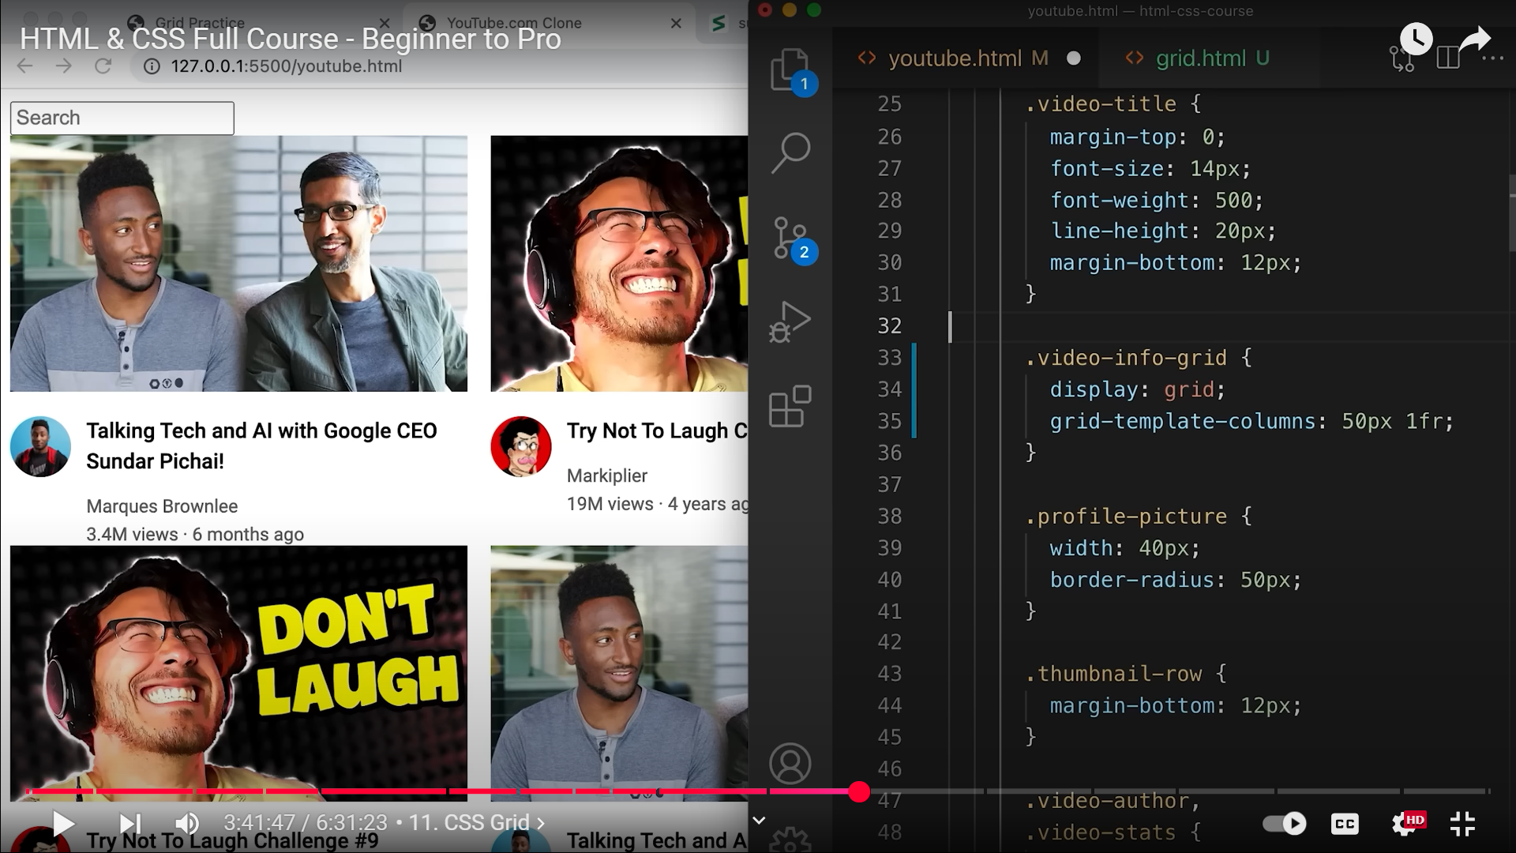 33, .video-preview CLASS STYLE REMOVED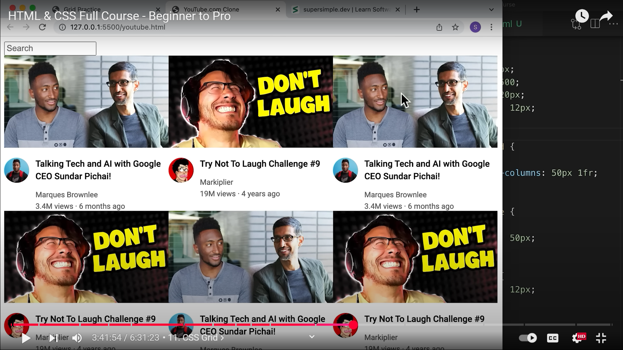 NOW WE HAVE TO ADD COLUMN GAP AND ROW GAP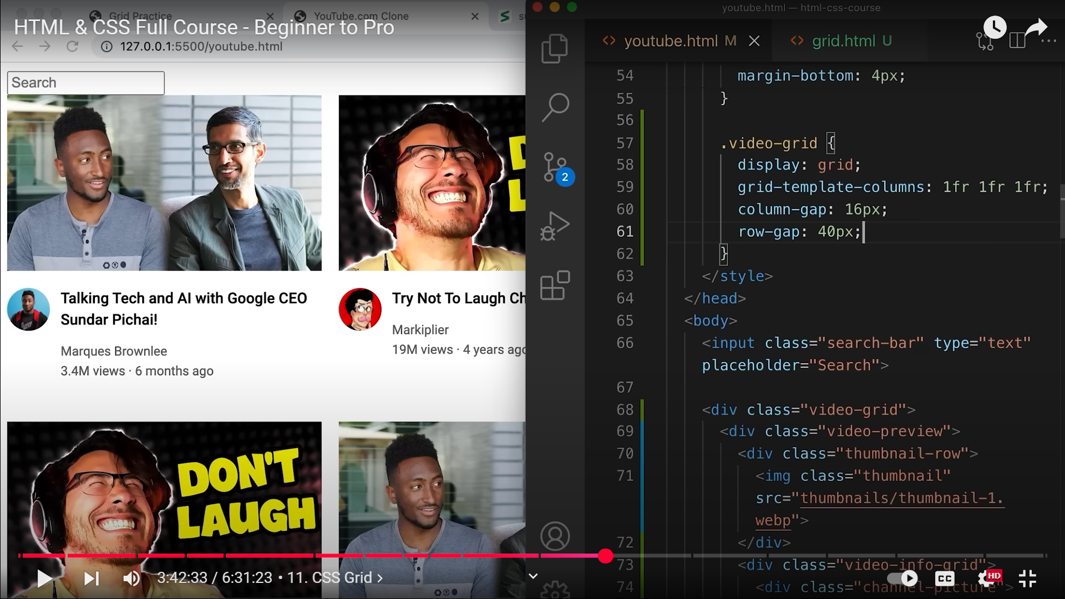 60,61**